 **54 Gardner St, Allston, MA. 6173717277. ls1993@bu.edu**

**Traffic Violations Case**

**Personal Injury Prediction**

Team Tigger

Peng Yuan

Shuo Li

Boston University

March 26, 2019

**Database Description**

The dataset is about the traffic violations information from all electronic traffic violations issued in Montgomery County of Maryland. The dataset is open to the public, so the unique information that can identify the vehicle, For Example, vehicle owner is avoided. The dataset is created in February 4, 2015 and updated in August 9, 2018. The dataset includes 1048575 tuples and 35 attributes. The attributes are:

Date of Stop; Time of Stop; Agency; SubAgency; Description; Location; Latitude; Longitude; Accident; Belts; Personal Injury; Property Damage; Fatal; Commercial License; HAZMAT; Commercial Vehicle; Alcohol; Work Zone; State; Vehicle Type; Year; Make; Model; Color; Violation Type; Charge; Article; Contributed To Accident; Race; Gender; Driver City; Driver State; DL State; Arrest Type; Geolocation

Dataset is retrieved by: <https://catalog.data.gov/dataset/traffic-violations-56dda>

**Data Mining Goal**

For this dataset, the goal is to predict whether a driver will get personal injury according to the following attributes: Accident, Belt, Property Damage, Commercial License, Alcohol, Vehicle Type, Year, Make, Model, Race, Color, Driver state and Gender. The class attribute is Personal Injury. We are using Weka and R to discover the relationship between selected attributes and the results.

**Data Mining Algorithms & Classifier**

**Attributes Selection:**

* CsfSubsetEval
* GainRatioAttributeEval
* InfomrationGainEval
* ChiSquaredAttributeEval
* Self-selection

**Classifiers:**

* Naïve Bayes
* J48
* OneR
* Random Forest

**Dataset Preprocessing**

**Removing the attributes that are not relevant using R**

We decide to use R tool to make the dataset preprocessing. In our initial database, there are total 35 attributes in the database, but we delete the unhelpful attributes for our goal. The deleted attributes are following: Data Of Stop, Time Of Stop, Agency, Sub Agency, Description, Location, Latitude, Longitude, Fatal, HAZMAT, Commercial Vehicle, Work Zone, State, Violation Type, Charge, Article, Contribute To Accident, Driver City, DL State, Arrest Type, Geolocation. The total deleted attributes are 21.

There are total 14 attributes that we are going to use in the data mining.

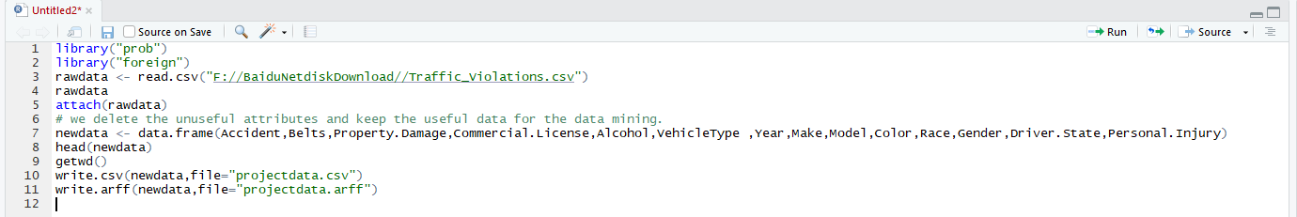

When we check the new dataset in the Weka, all the values in the Accident attribute is No. So the Accident attribute will not make influence in the class attribute. We delete the attribute.

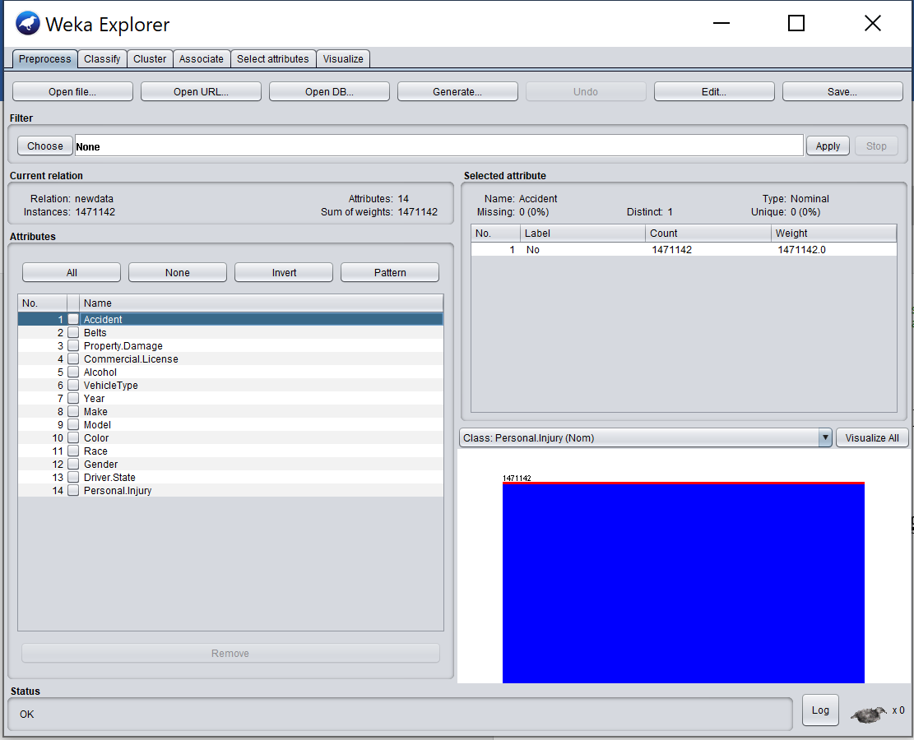

**Missing values handling**

By checking all the attributes of the new dataset, we find some attributes that contain the Missing values. The attribute Year has 9020 missing values, the Make has 15 missing values, the Model has 68 missing values.

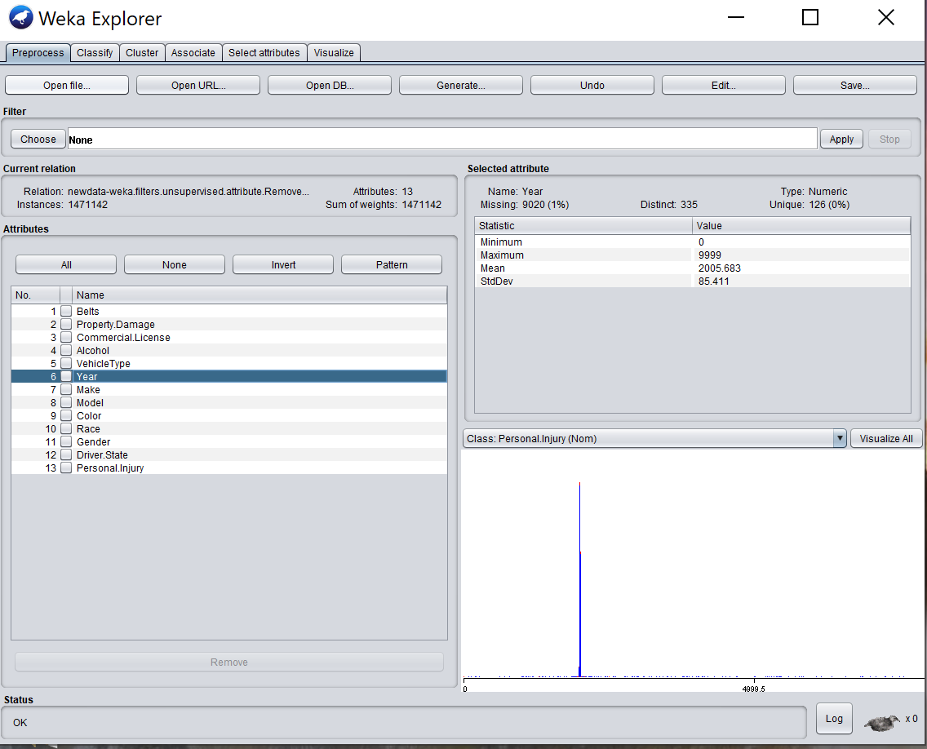

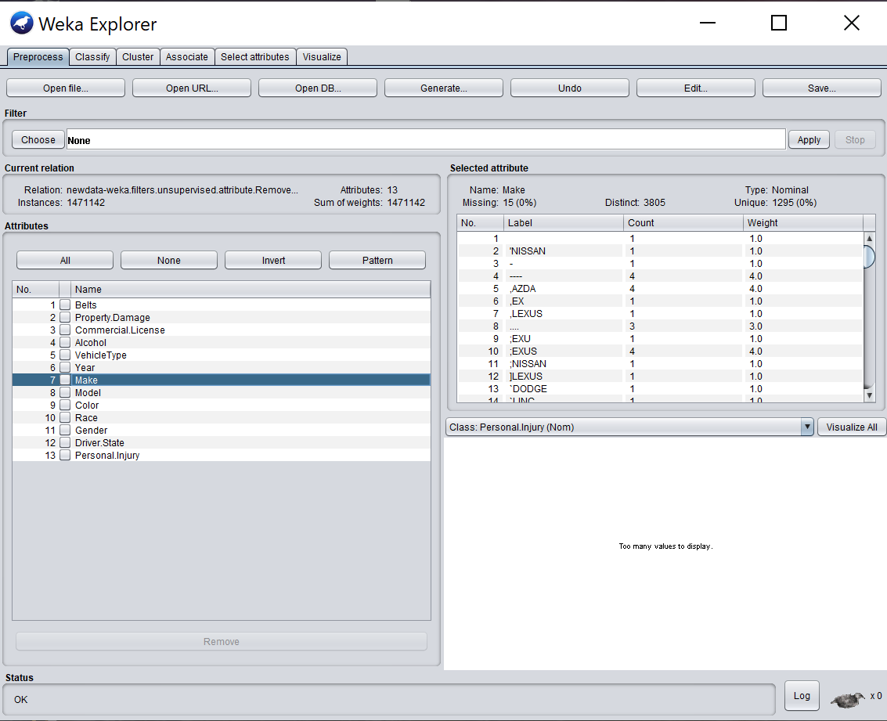

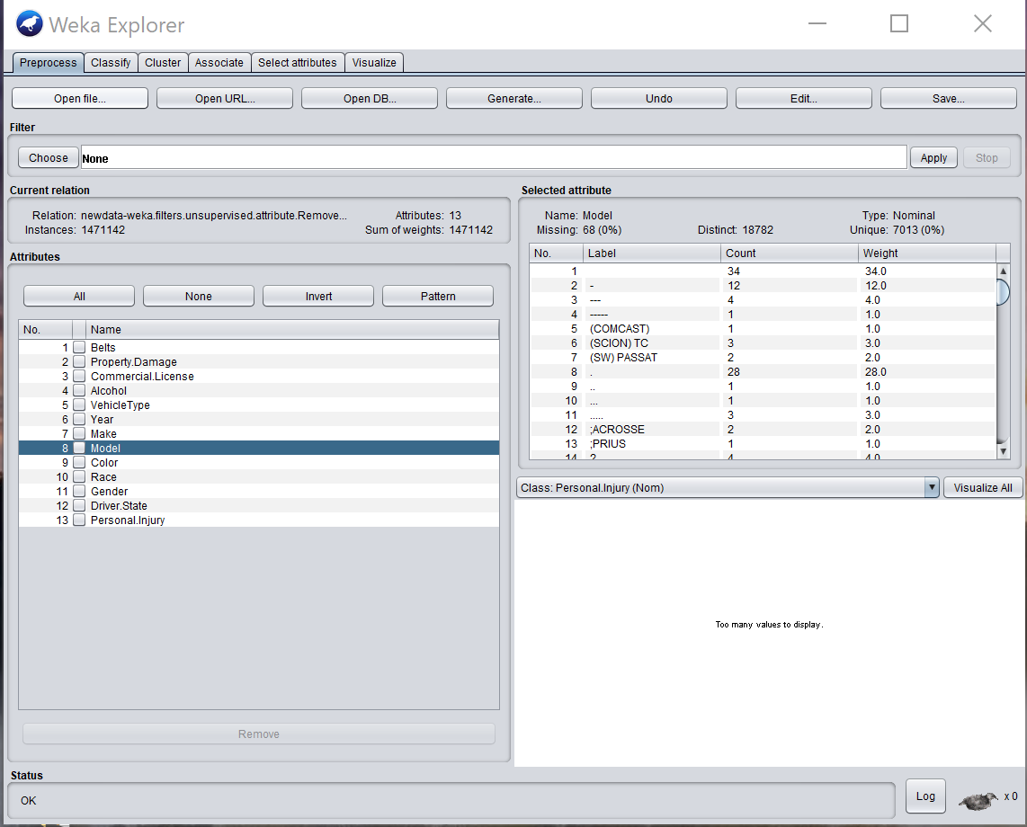

For the missing data in the three attributes, we are going to use ReplaceMissingValues filter to replace all the missing values in the attributes by “mean” or “median”. In such way, the total number of the instances is not influenced.

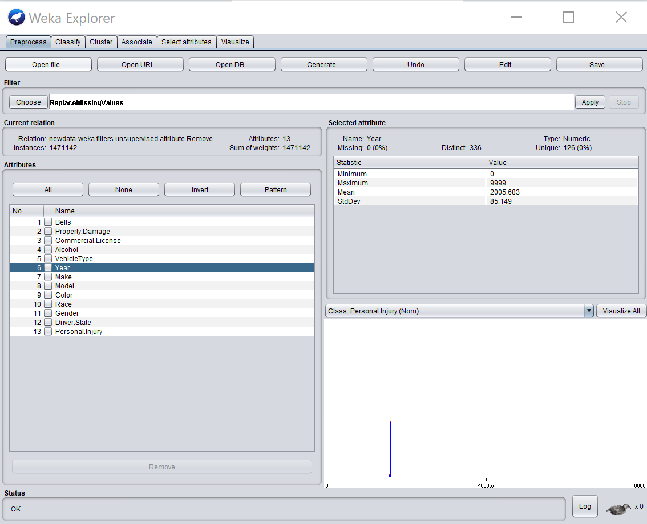

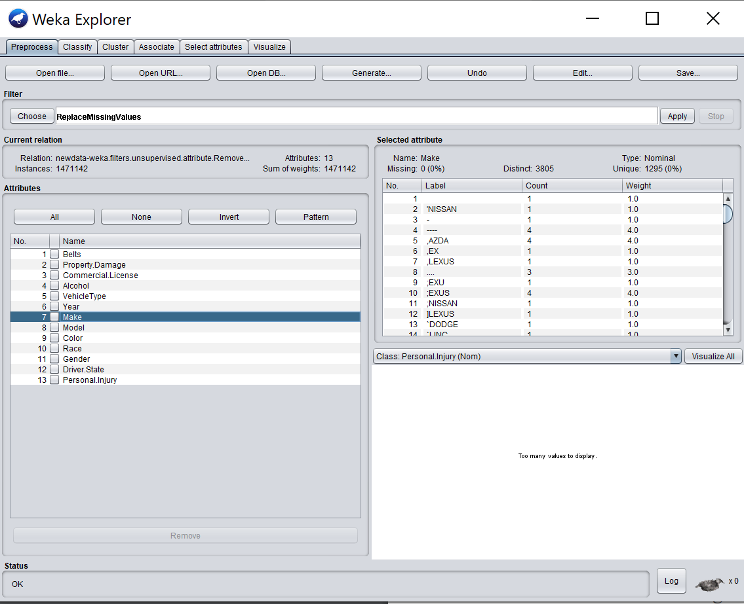

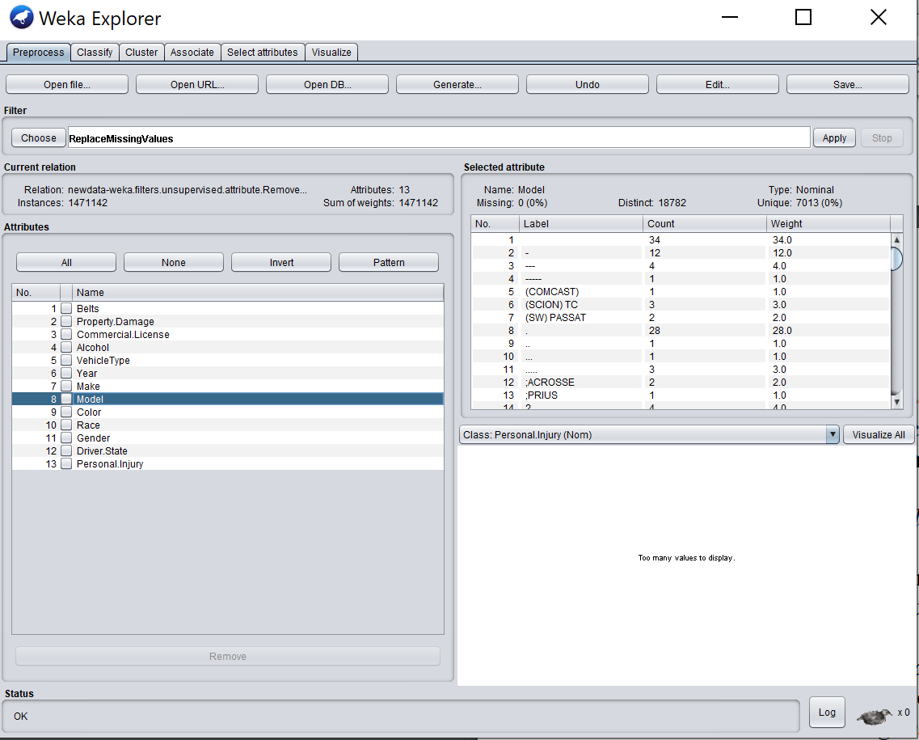

**Removing outliers (outlier detection with IQR)**

Because there are many extreme values in the Year attributes to make the noisy, like “0” and “9999”. There are also some numbers like “15xx” in the attribute Year. It is important to remove the outliers in the data set to guarantee the integrity of the dataset to make the data mining.

There are total 8352 values in Year attribute.

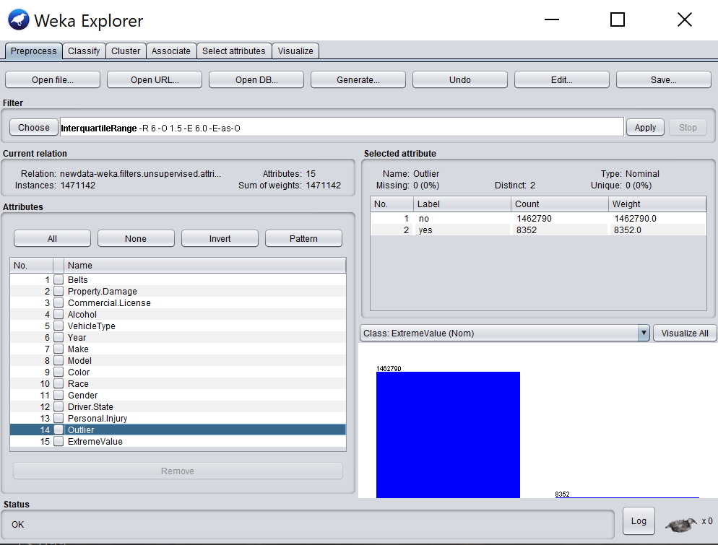

After removing the outliers from the whole dataset by using filter RemoveWithValues, the number of the instances in the data set decrease from 1471142 to 1462790.

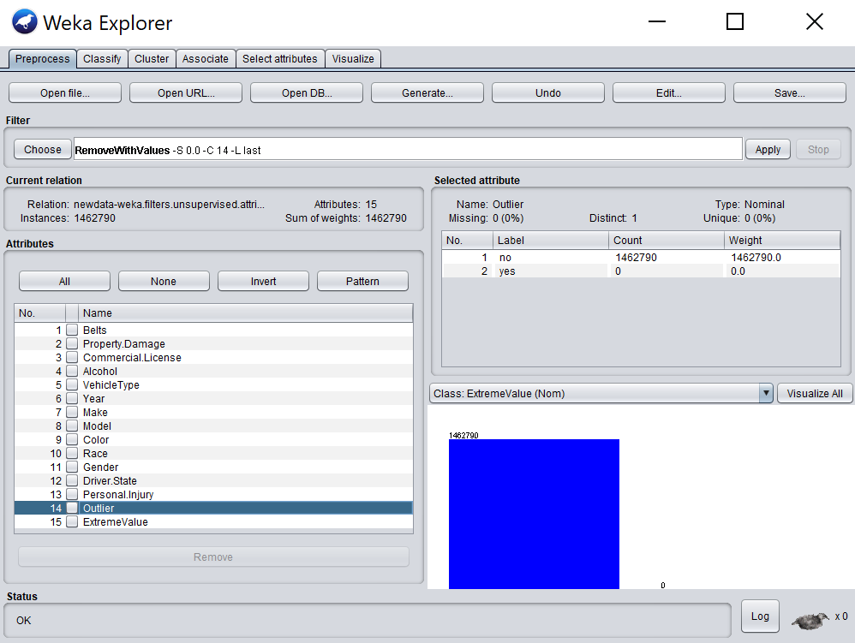

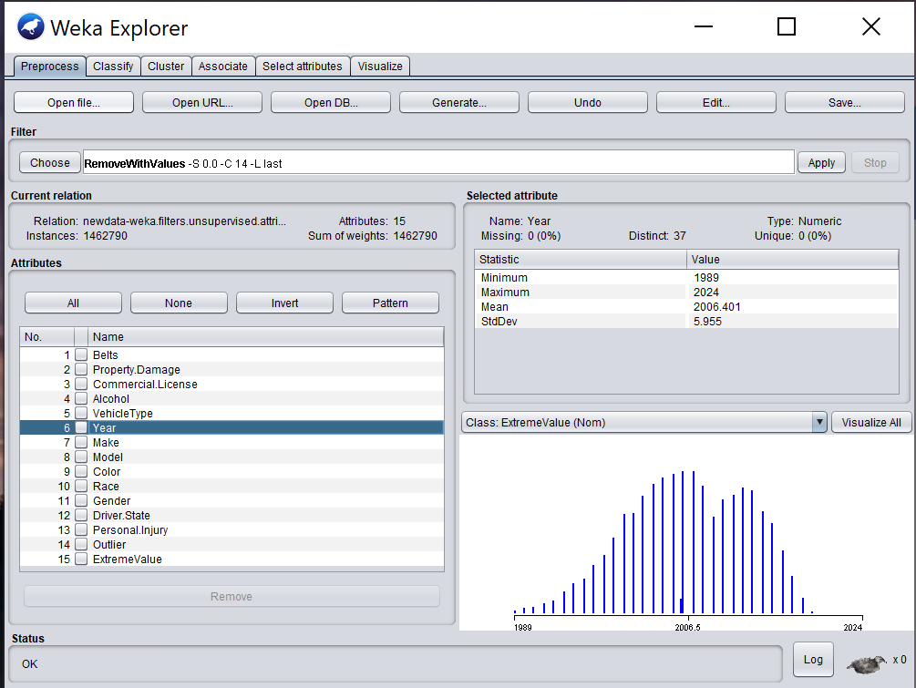

**Discretization**

In the part, we discretize the Year attribute to a nominal attribute with 7 distinct values by using discretize filter.

Before discretization:

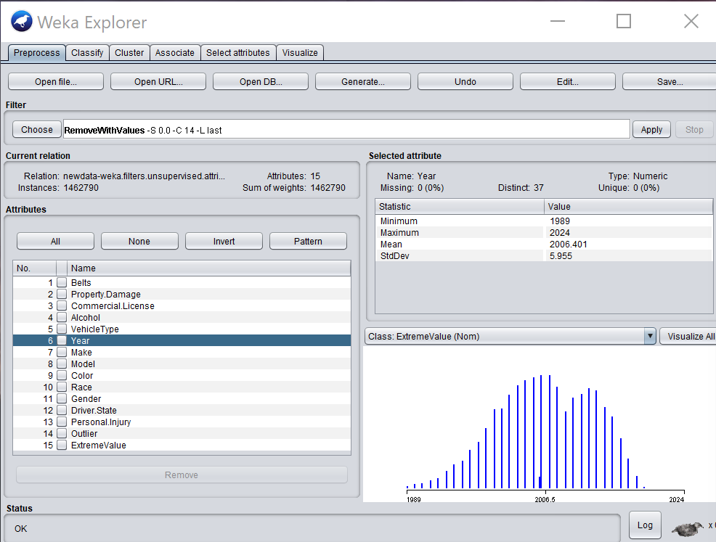

After discretization:

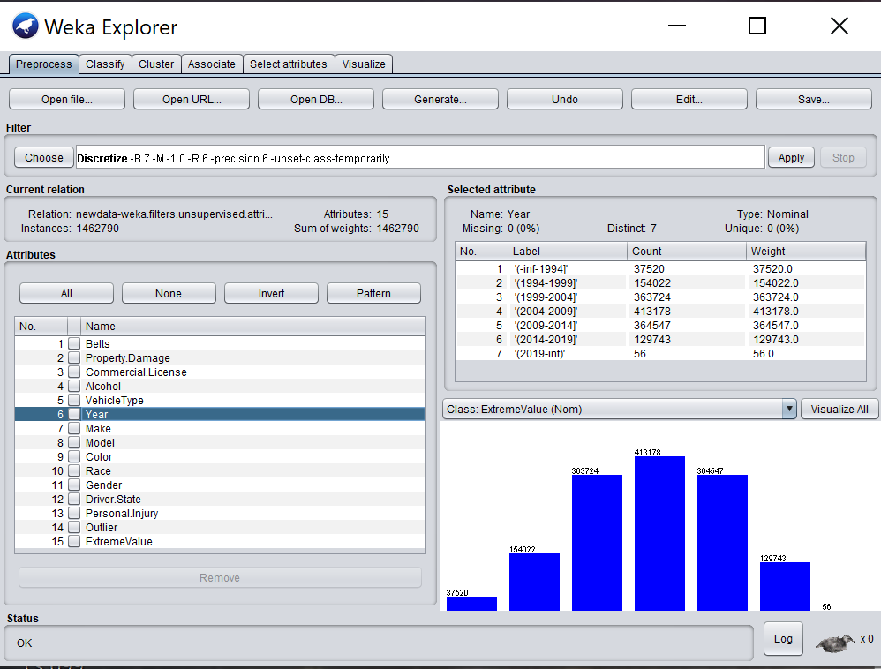

**Dividing 1 percent dataset as the new database**

Because the original dataset is too big for Weka to use SMOTE to deal the unbalanced data. We decide to use only 1 percent dataset from the original dataset to make the data analysis. The new dataset is named as preprocessing1.

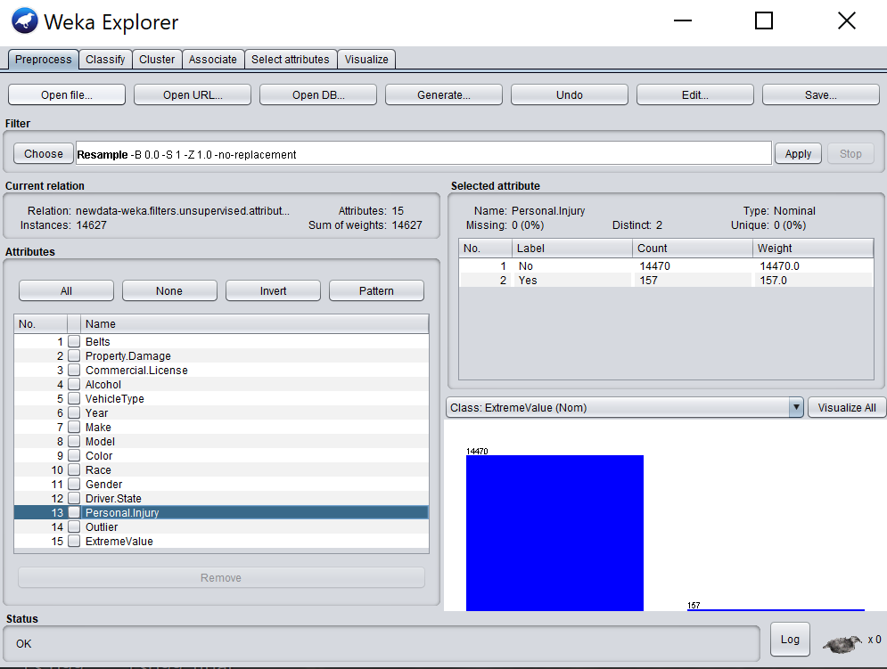

**Splitting Training dataset and Test dataset**

Dividing the preprocessing1 dataset into Training dataset taking 2/3 percent and Test dataset taking 1/3 percent.

Training dataset:

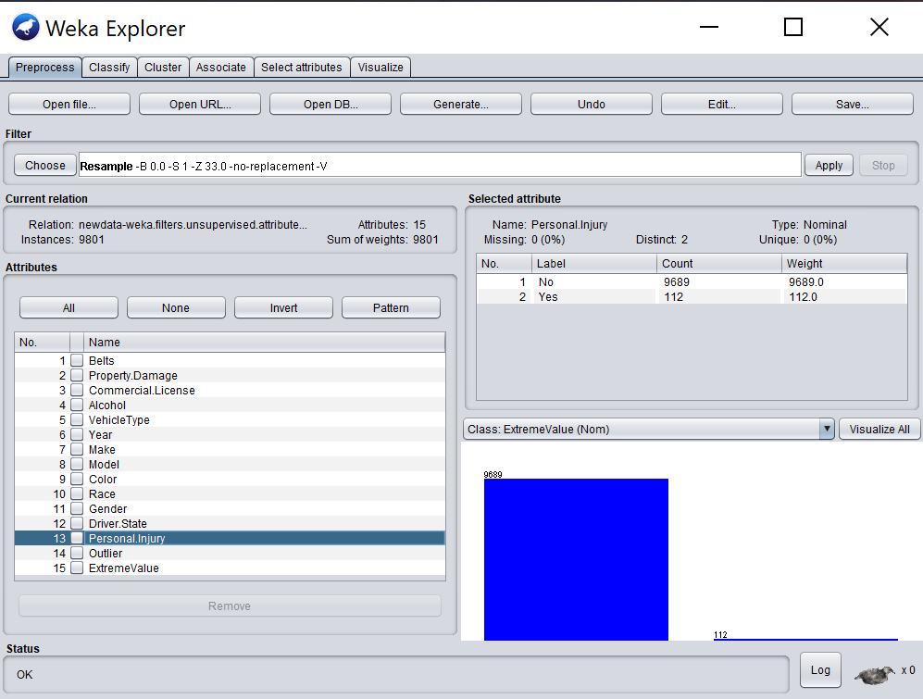

Test dataset:

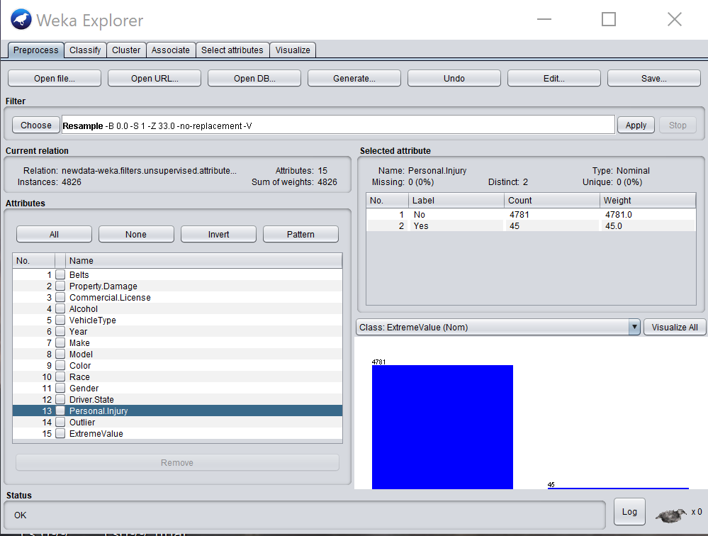

**Systematic Oversampling**

After discretization, we find that the class attribute—Personal Injury in the training dataset is extremely unbalanced, as shown below:

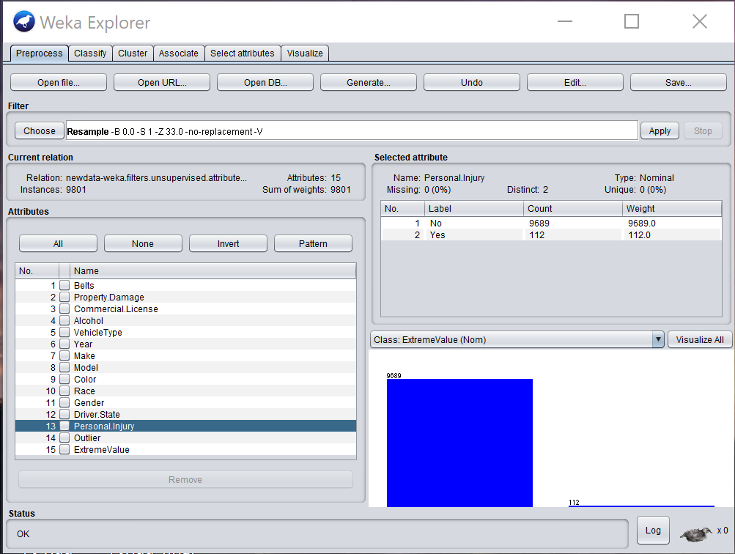

We decide to use R to oversample dataset by the package SMwR using SMOTE method. The unbalanced data will make much negative influence on the accuracy of the performance. The R code is following:

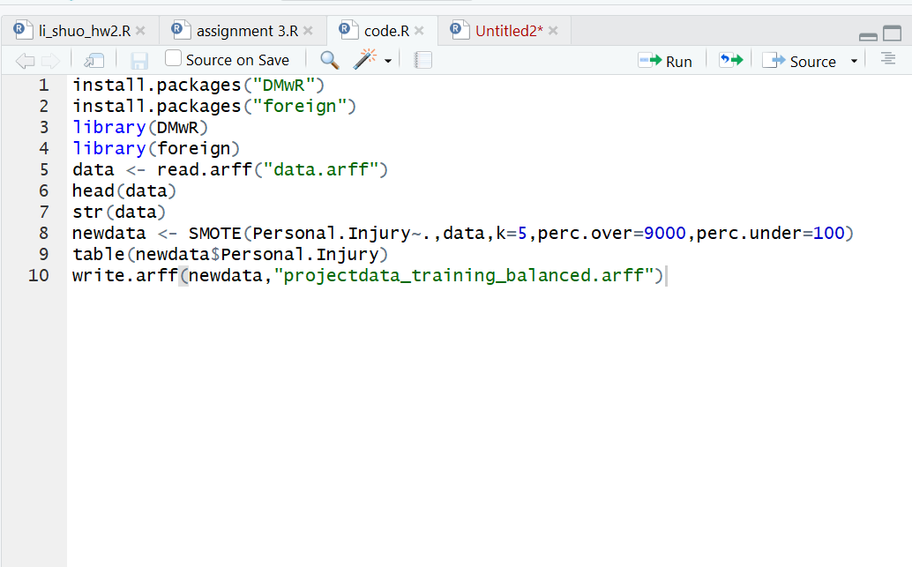

After smote function, we explore the new dataset in the Weka to have the balanced data:

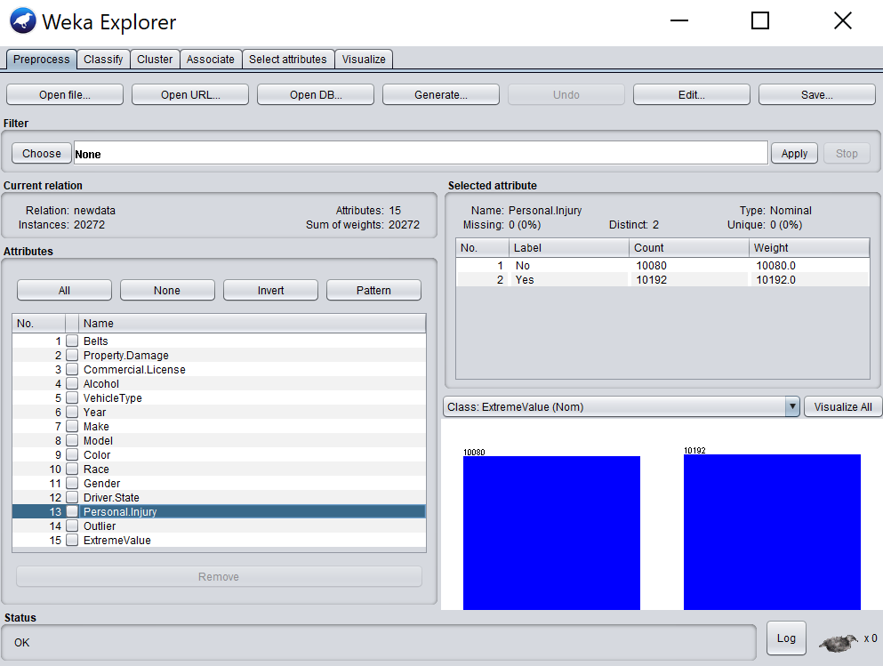

**Attributes Selection and Algorithm**

After the balancing the training dataset, we are going to select the attributes that will be relevant to the class attribute. There are four algorithms used in the selecting of the attributes: ChiSquaredAttributeEval, GainRatioAttributeEval, InfomrationGainEval, CsfSubsetEval and we also select the attributes by ourselves as the fifth method.

1. **CsfSubsetEval**

“The CsfSubsetEval valuates the worth of a subset of attributes by considering the individual predictive ability of each feature along with the degree of redundancy between them. Subsets of features that are highly correlated with the class while having low intercorrelation are preferred.”

From: <http://weka.sourceforge.net/doc.dev/weka/attributeSelection/CfsSubsetEval.html>

We use the CsfSubsetEval with search method: BestFirst. It selects six attributes and one class attribute to build the classification model.

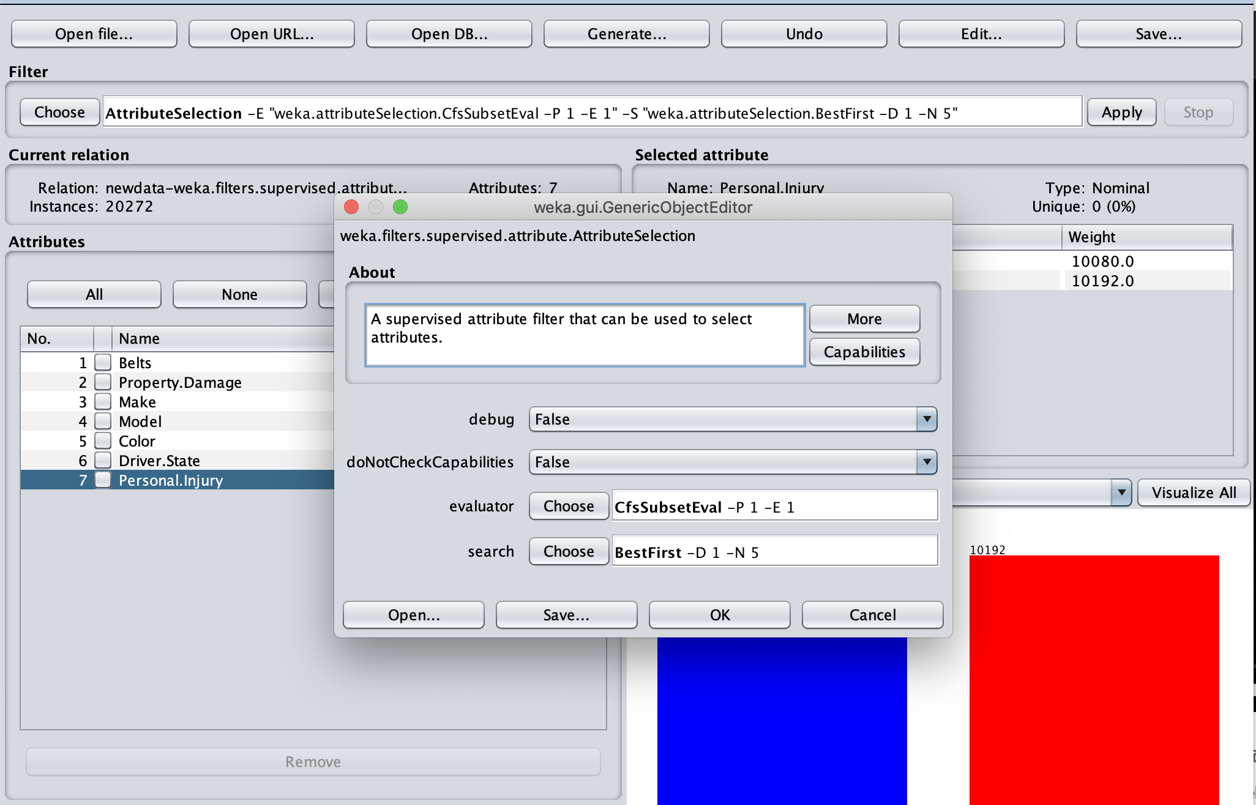

We are going to use the following four classifiers to build the model and test the results. We set the cross-validation folds = 10.

**NaiveBayes:**

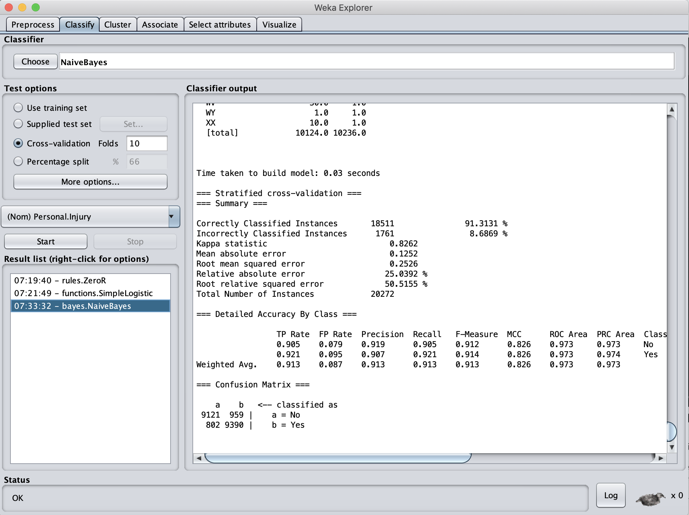

**J48**

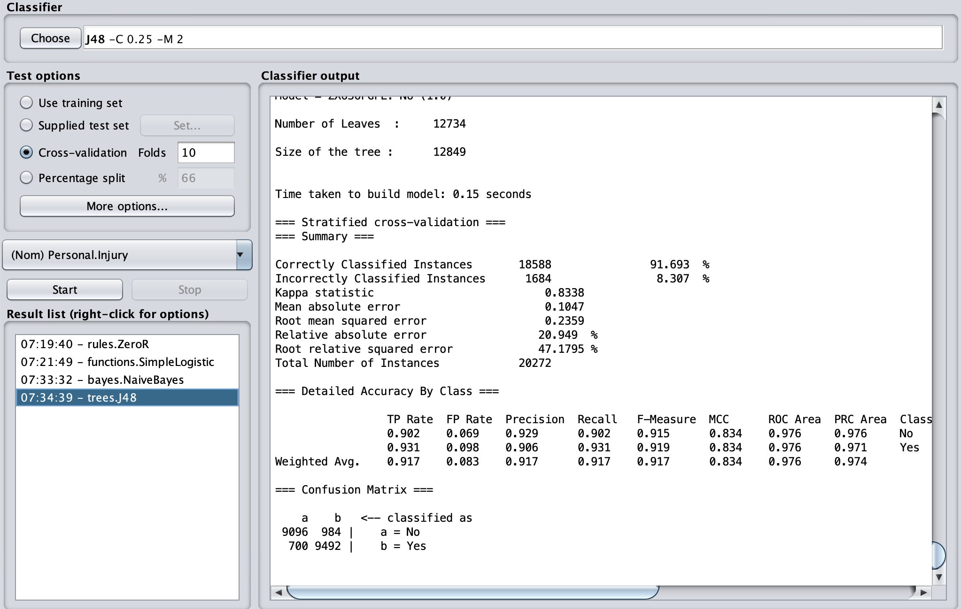

**OneR:**

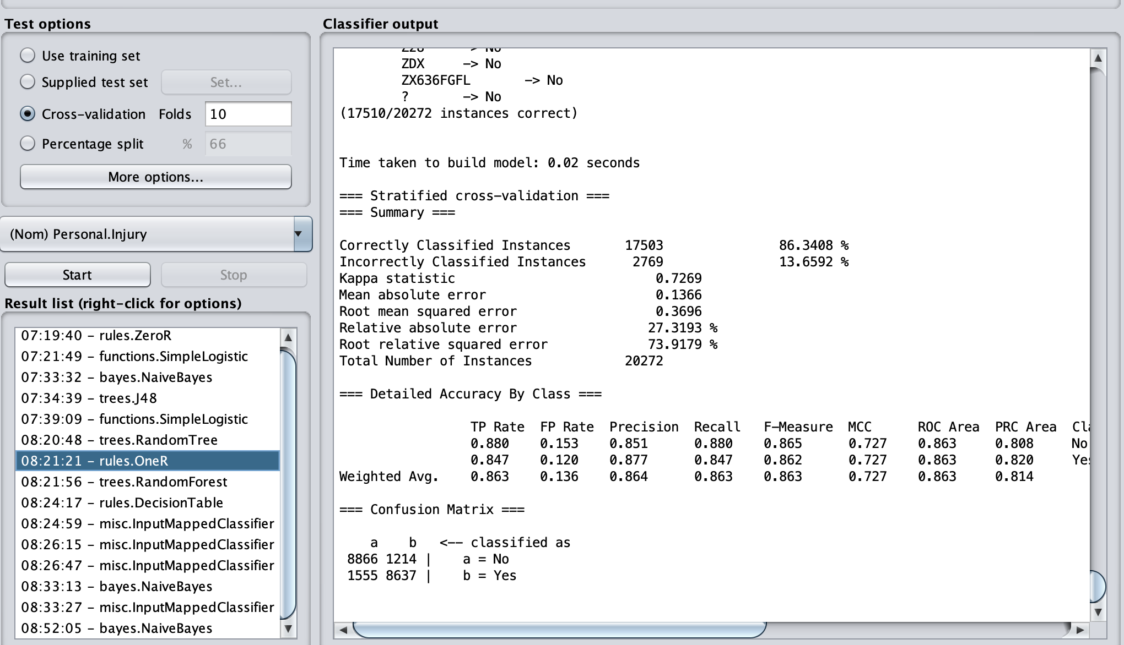

**RandomForest:**

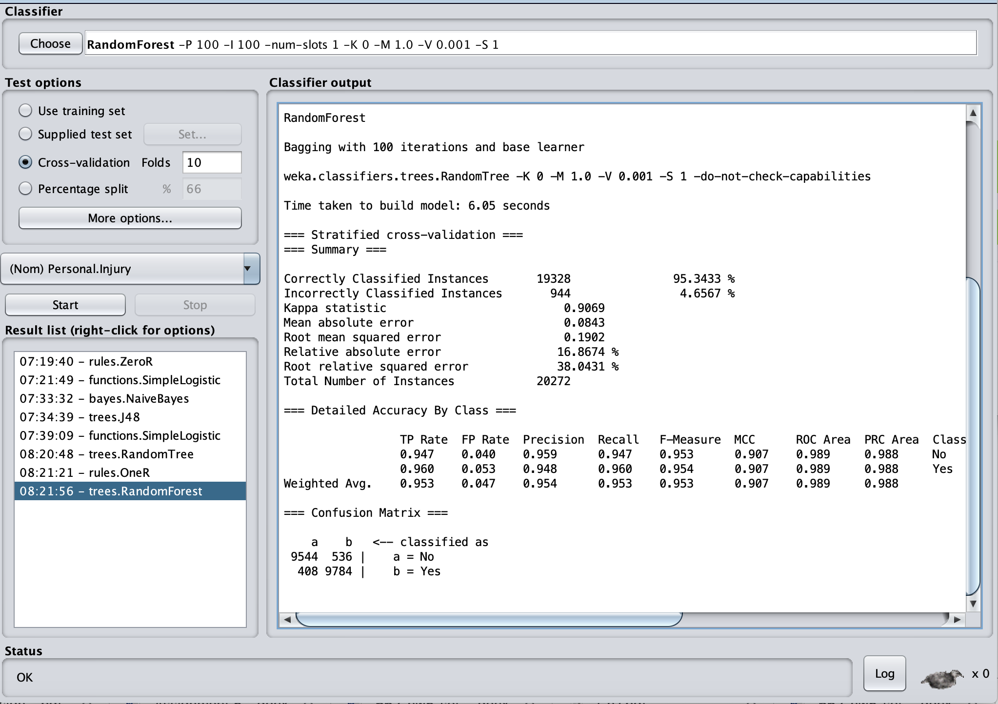

**Compare the test results:**

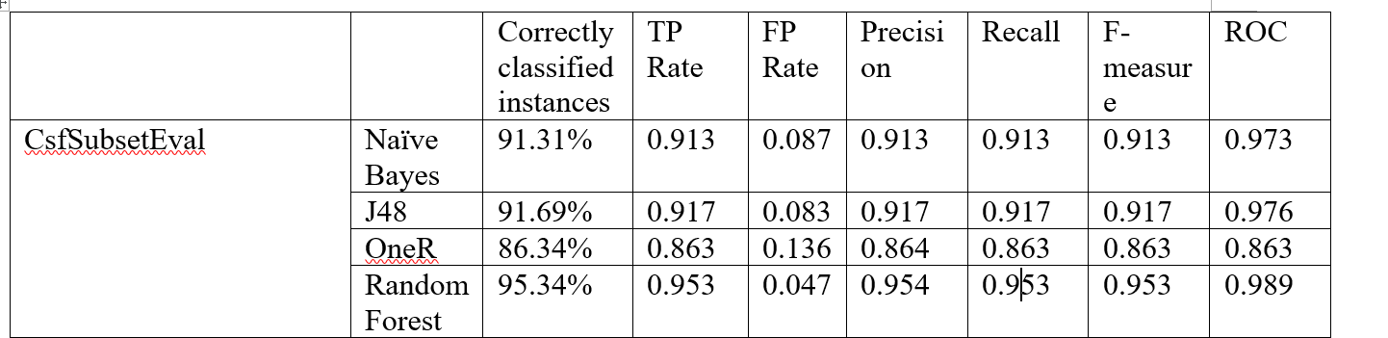

From the test results above, we can slightly see that the RandomForest has the highest accuracy which is 95.3433% of the Correctly Classified Instances. And also the Random Forest also has the highest ROC which is 0.988. So we can think that the CsfSubsetEval attribute selection method with Random Forest classifier has the best performance in these four models.

1. **GainRationAttributeEval**

“The GainRationAttributeEval Evaluates the worth of an attribute by measuring the gain ratio with respect to the class”.

From: <http://weka.sourceforge.net/doc.stable/weka/attributeSelection/GainRatioAttributeEval.html>

We use the AttributeSelection evaluator GainRationAttributeEval with ranker search and then just select the top 5 attributes plus class attribute to build the classification model.

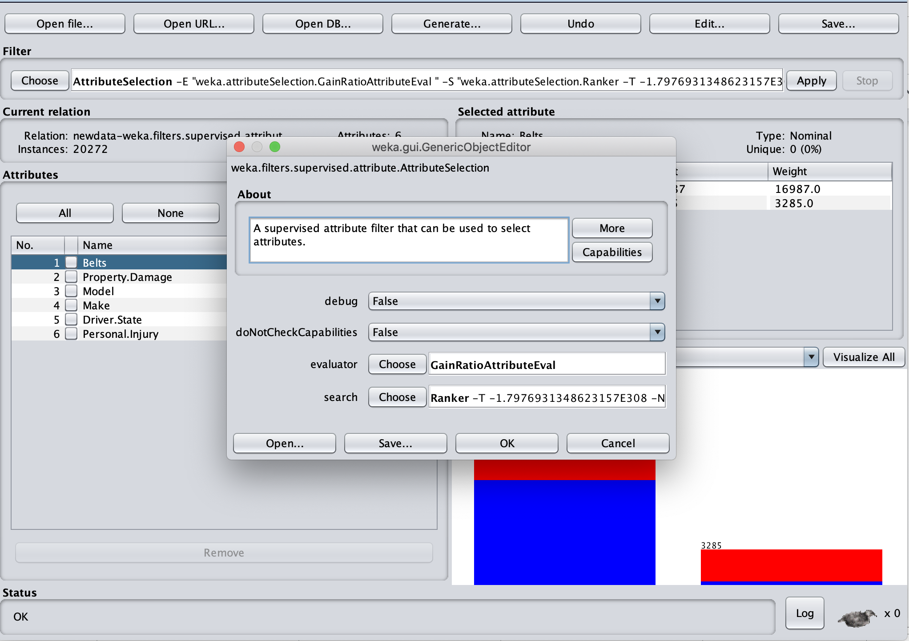

**Naive Bayes:**

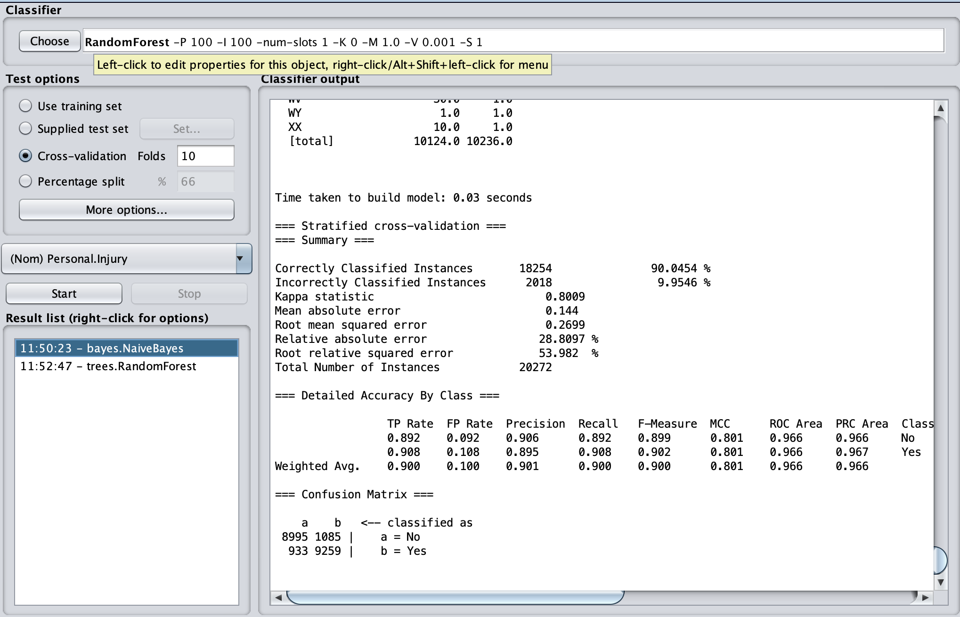

**J48:**

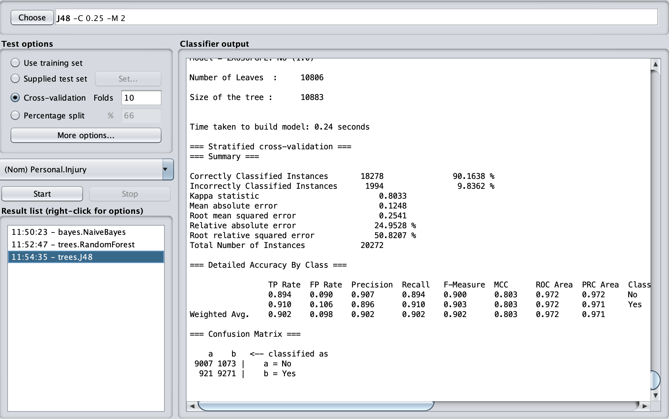

**OneR**: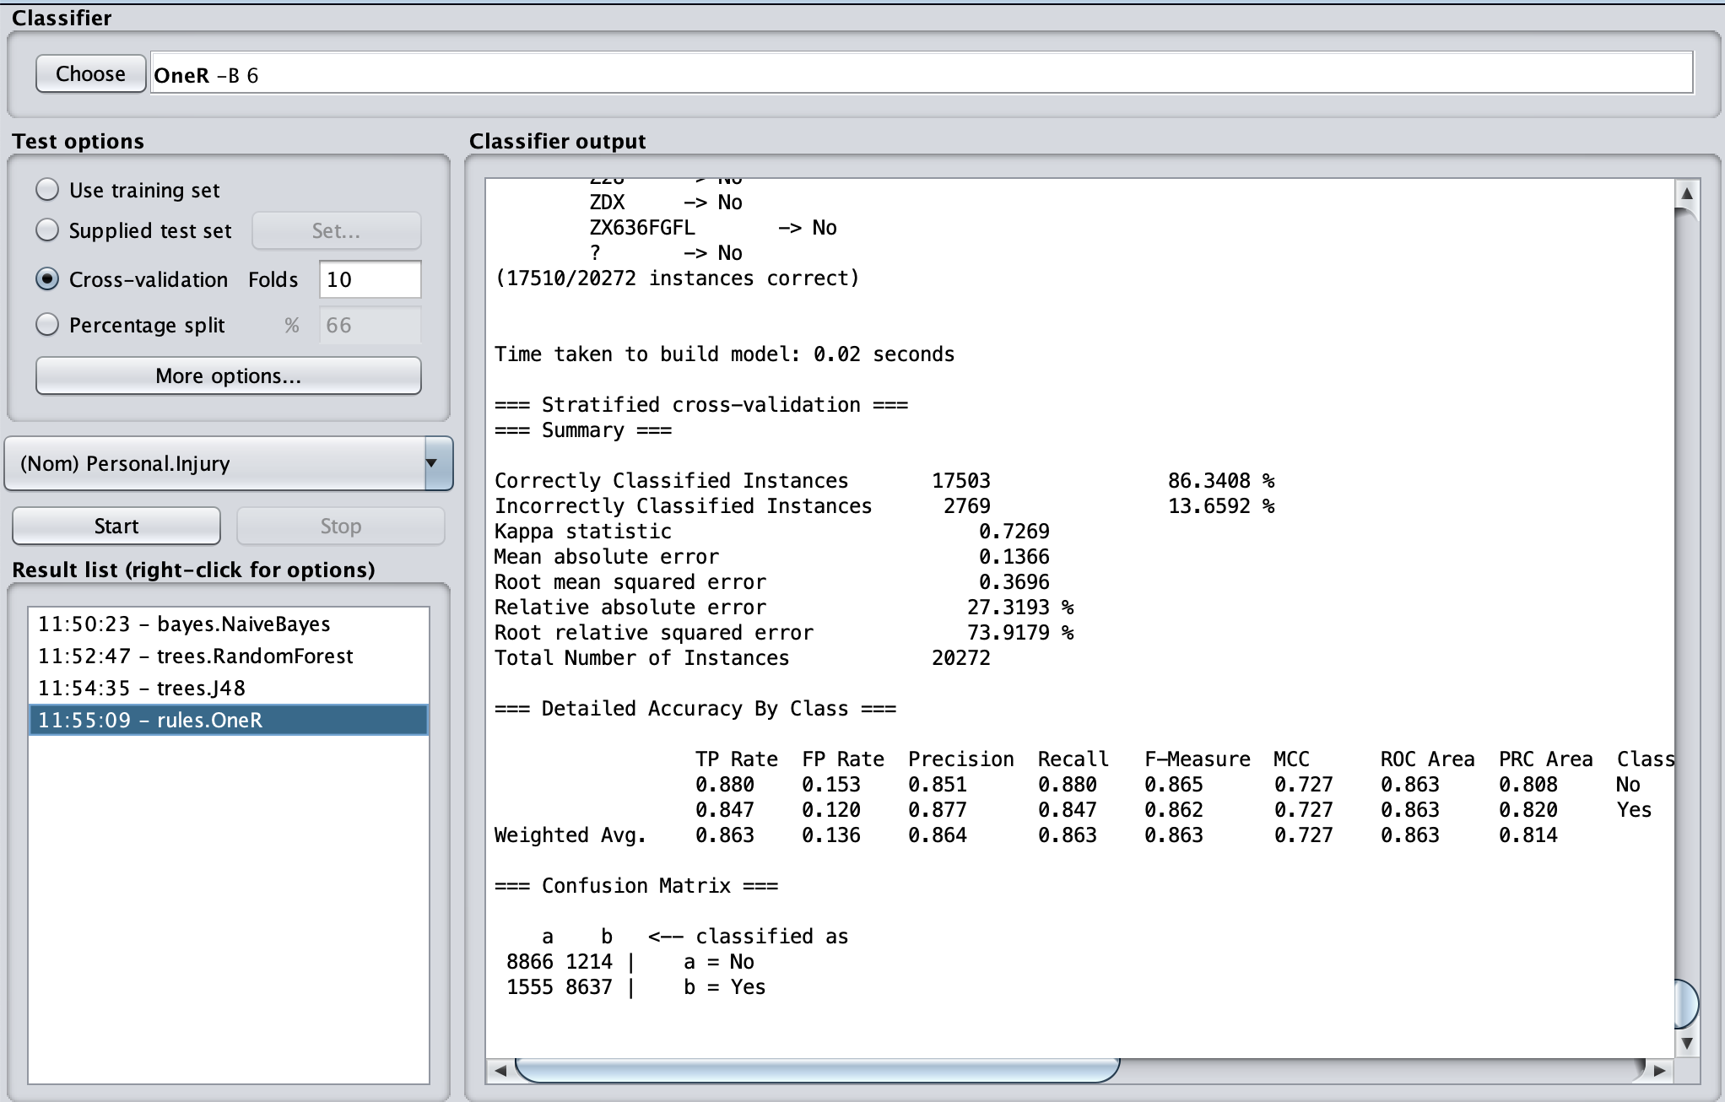

**RandomForest**:

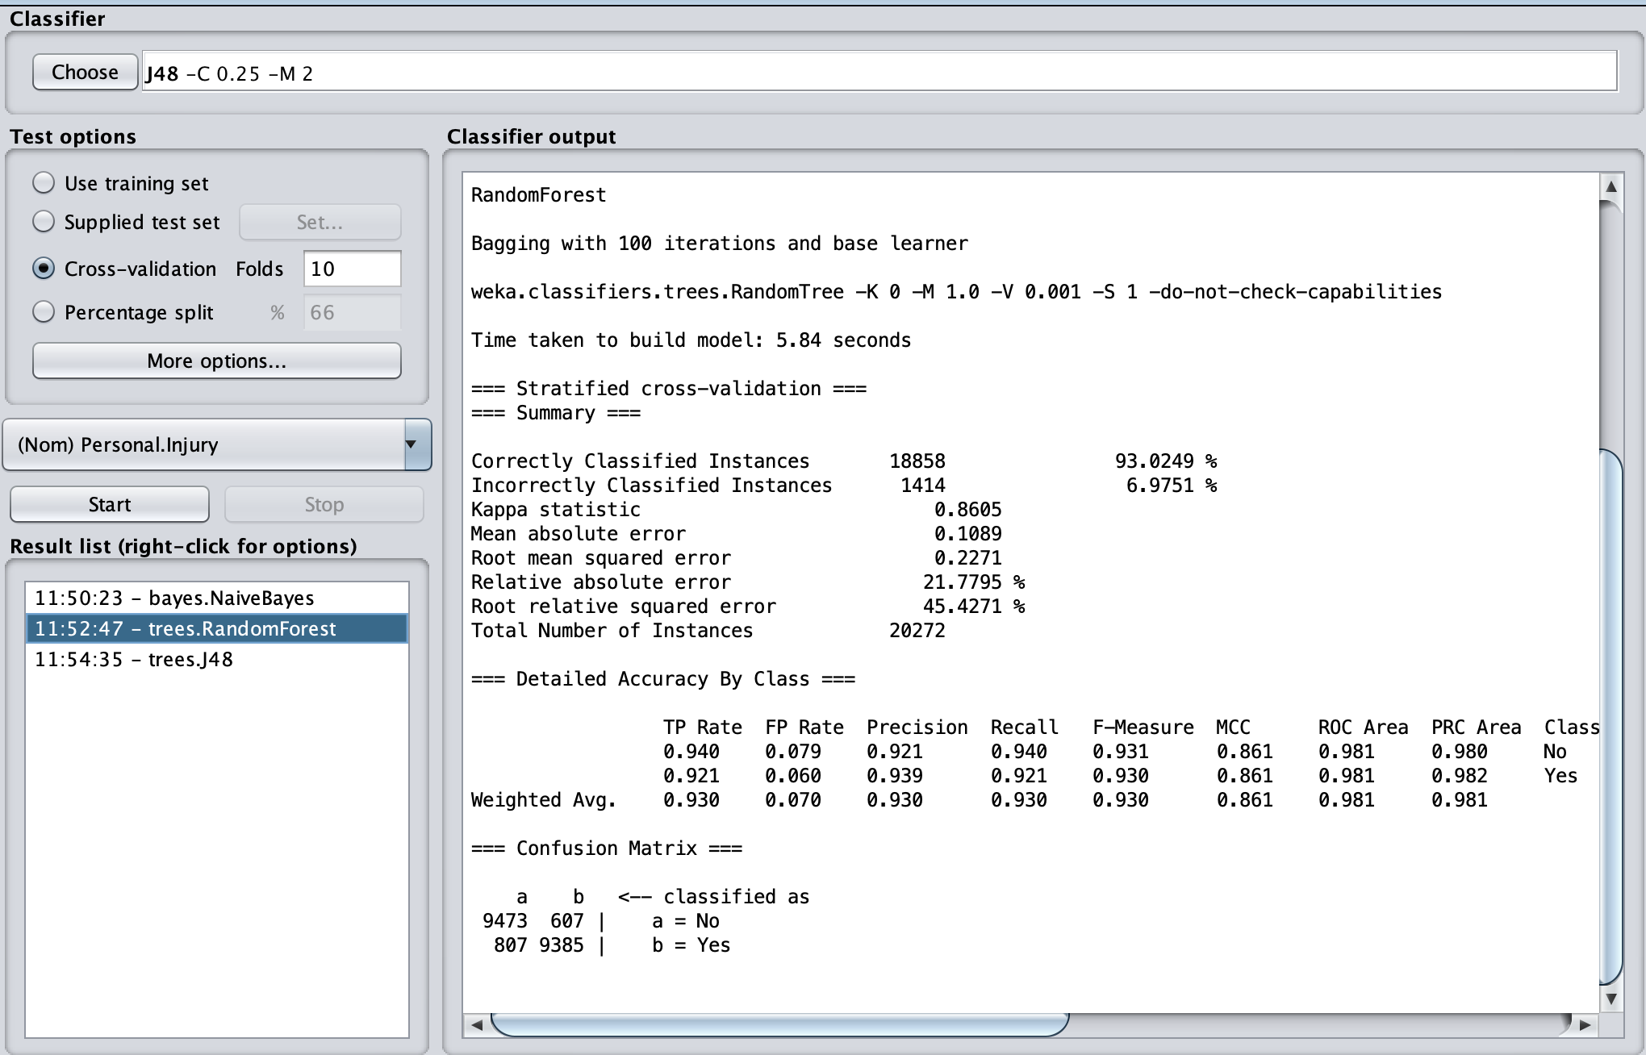

**Compare the test:**

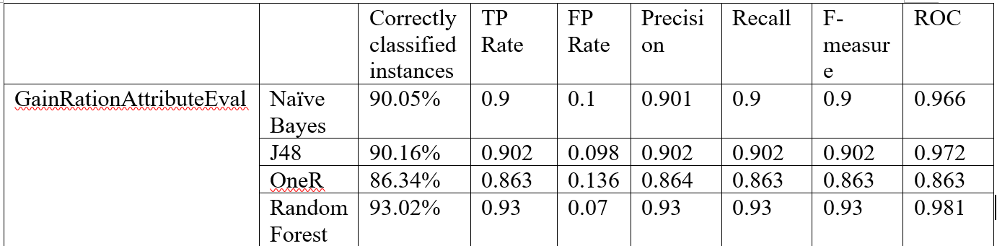

From the test results show above, we can find that The RandomForest has the biggest accuracy(93.0249%) of the Correctly Classified Instances. And also is has the largest ROC value which is 0. 981. So we can conclude that for the GainRationAttributeEval, the RandomForest classifier algorithm has the best performance among these four algorithms.

1. **InfoGainAttributeEval**

“The InfoGainAttributeEval Evaluates the worth of an attribute by measuring the information gain with respect to the class. “

<http://weka.sourceforge.net/doc.dev/weka/attributeSelection/InfoGainAttributeEval.html>

We select the selection method with InfoGainAttributeEval and ranker search, then we just need top 5 attributes which have the highest infogain and do the classification model.

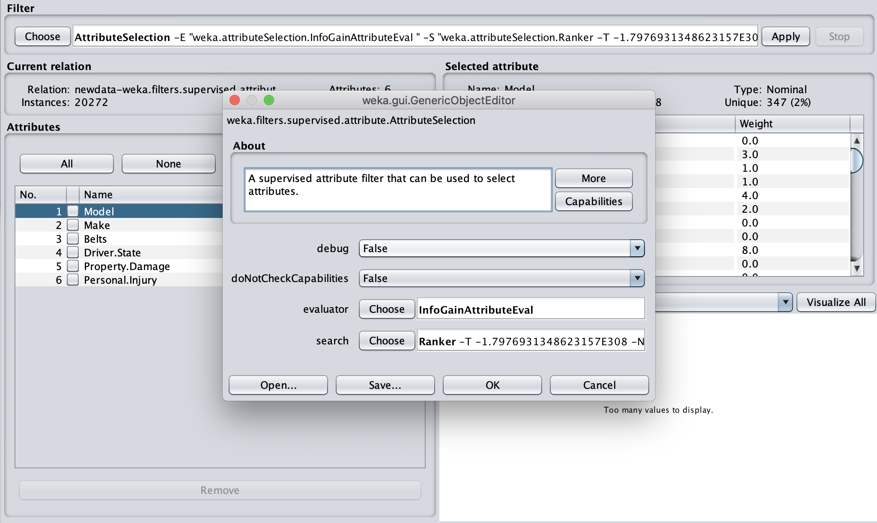

**Naive Bayes:**

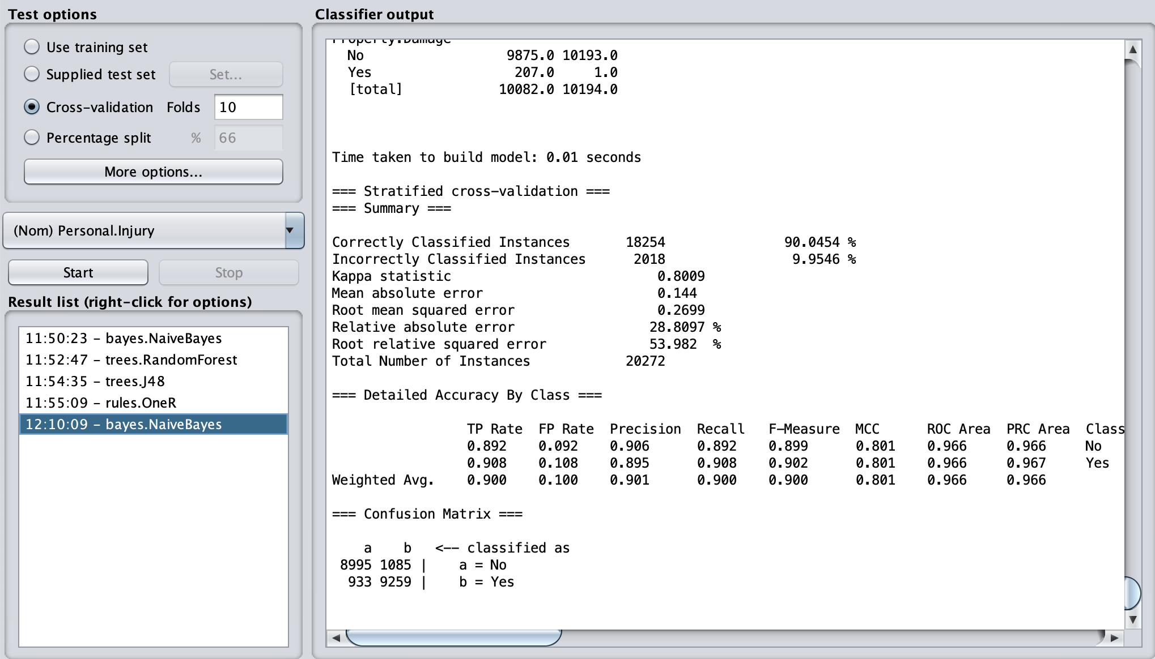

**J48:**

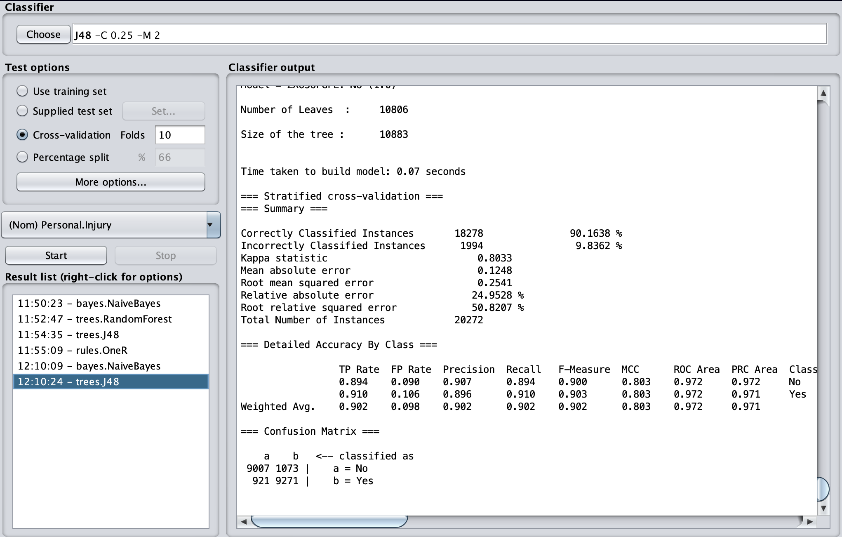

**OneR:**

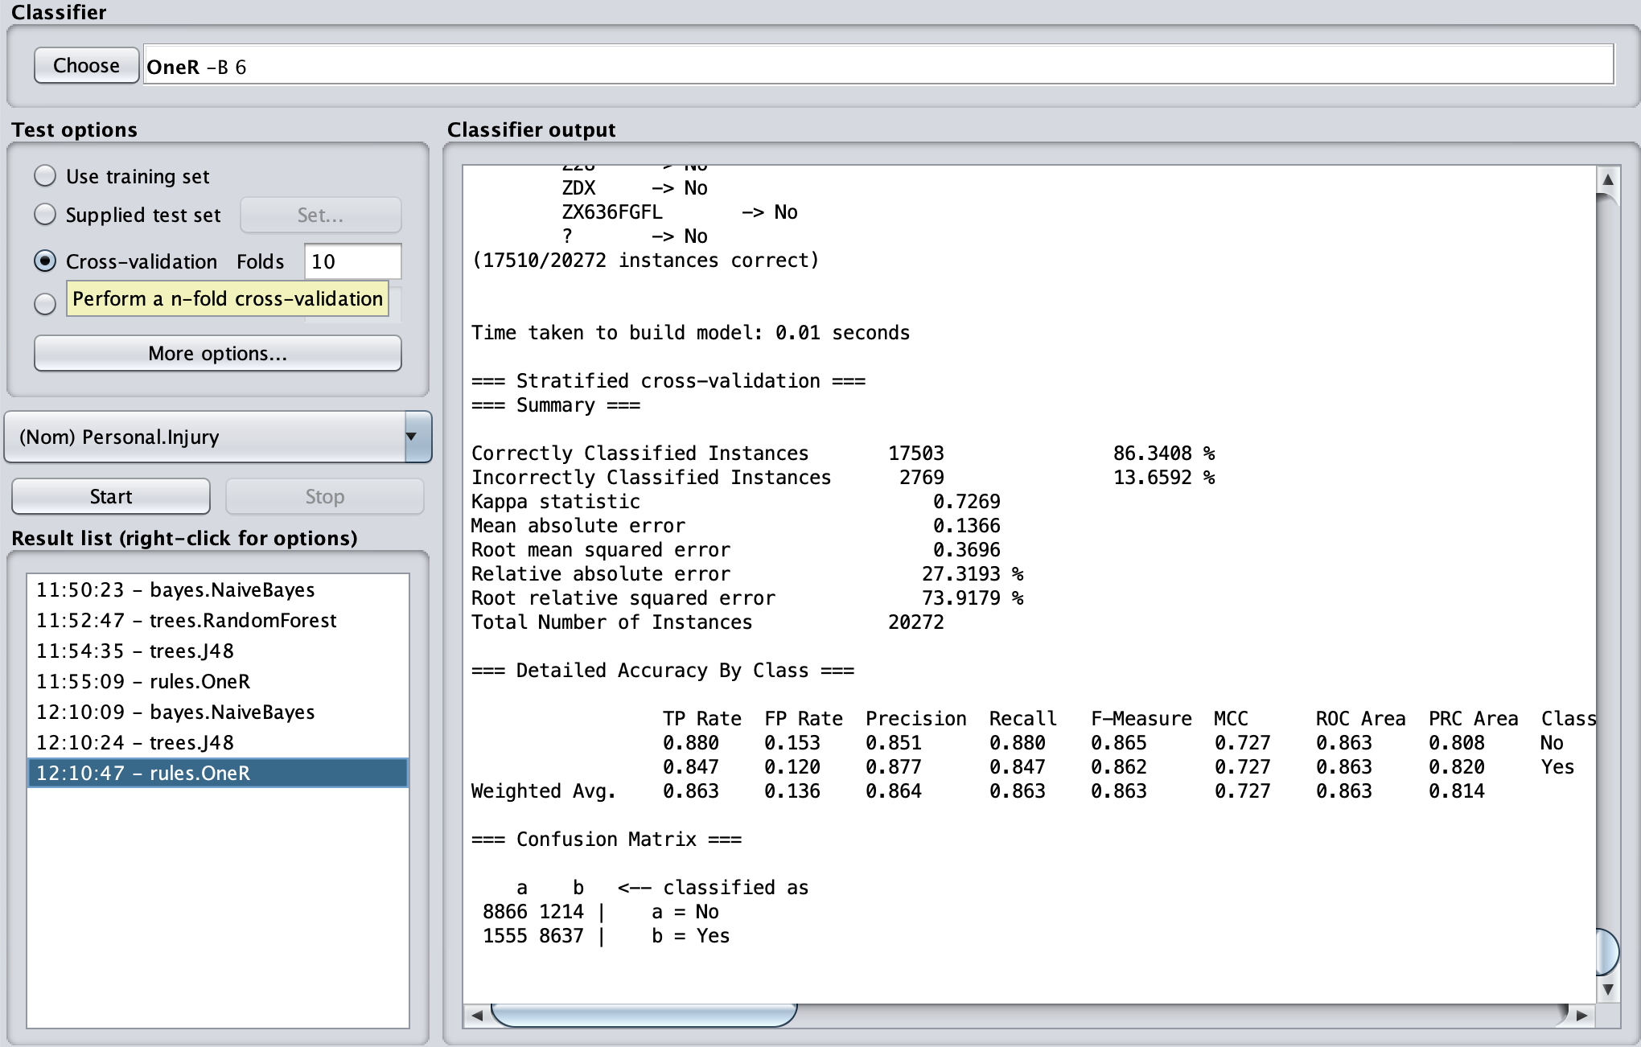

**RandomForest:**

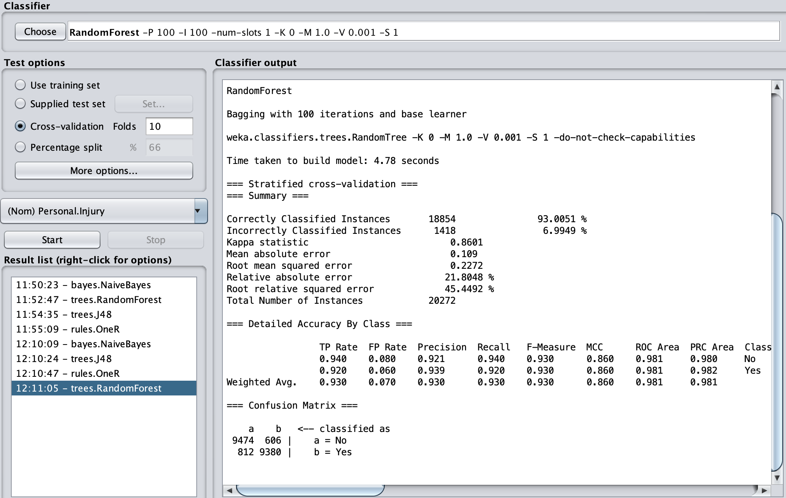

**Compare the test results:**

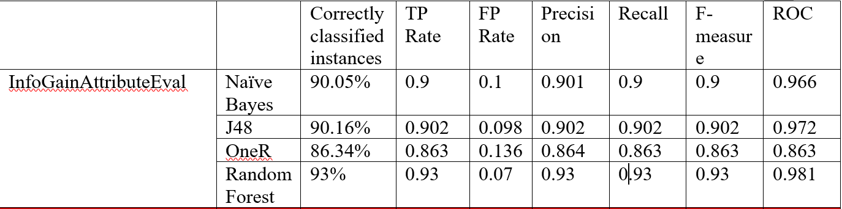

From the test results show above, we can see that the RandomForest has the highest accuracy of Correctly Classified Instances. And also the RandomForest has the highest ROC rather than other three algorithms. So we can conclude that the RandomForsest has the best performance when we use infoGainAttributeEval and ranker search.

1. **ChiSquaredAttributeEval**

“Evaluates the worth of an attribute by computing the value of the chi-squared statistic with respect to the class. “

<http://weka.sourceforge.net/doc.stable/weka/attributeSelection/ChiSquaredAttributeEval.html>

We select ChiSquaredAttributeEval and search method is Ranker to build classification model.

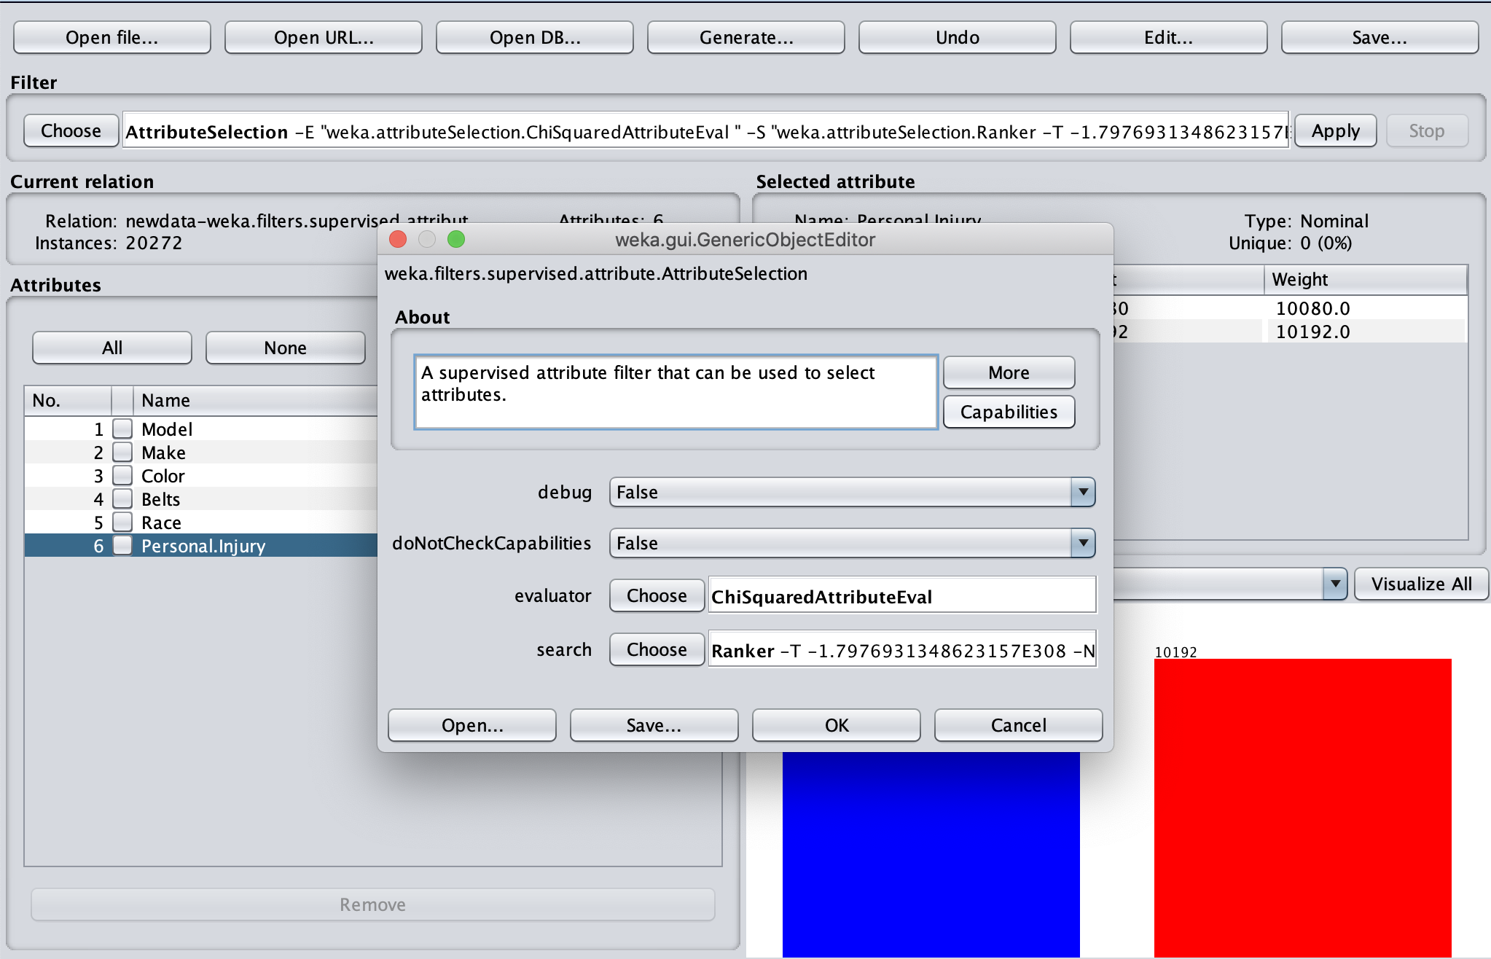

**Naive Bayes:**

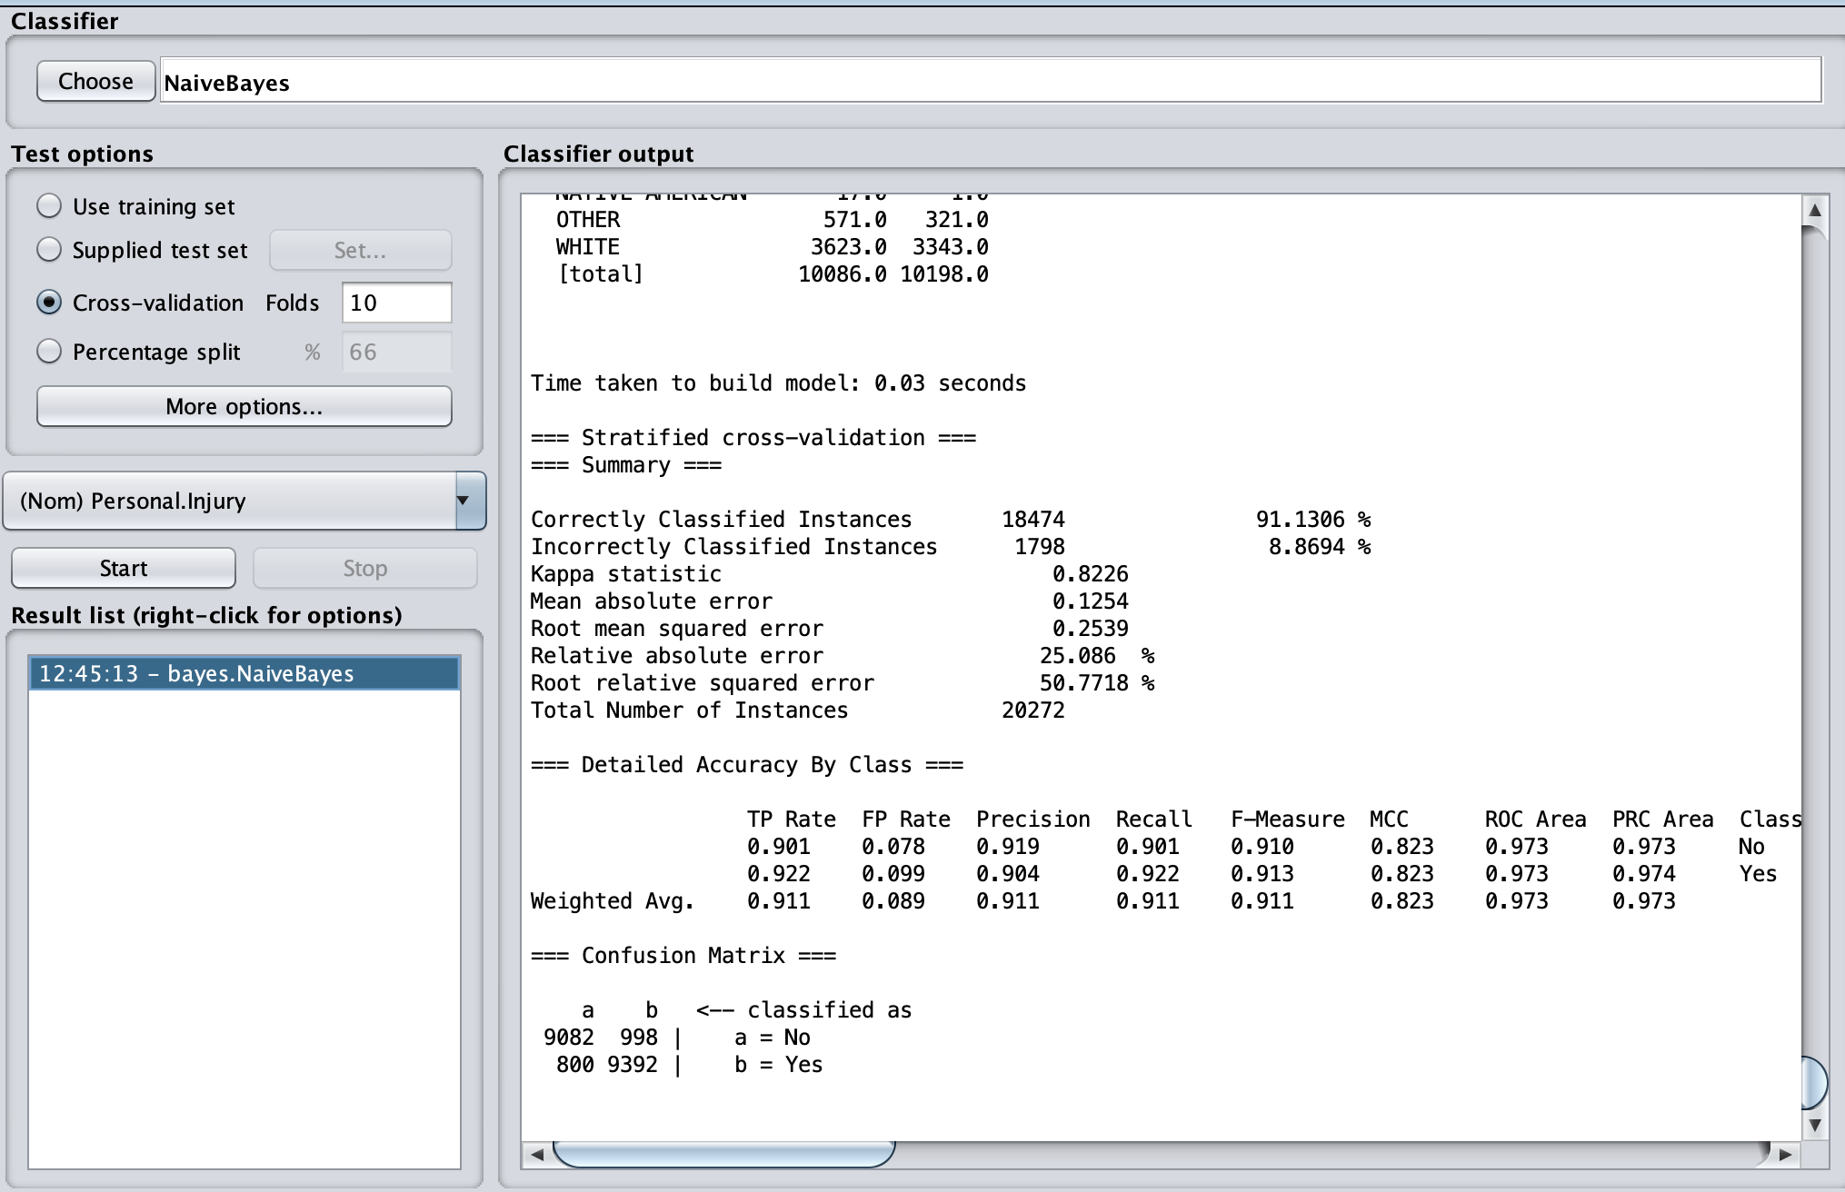

**J48:**

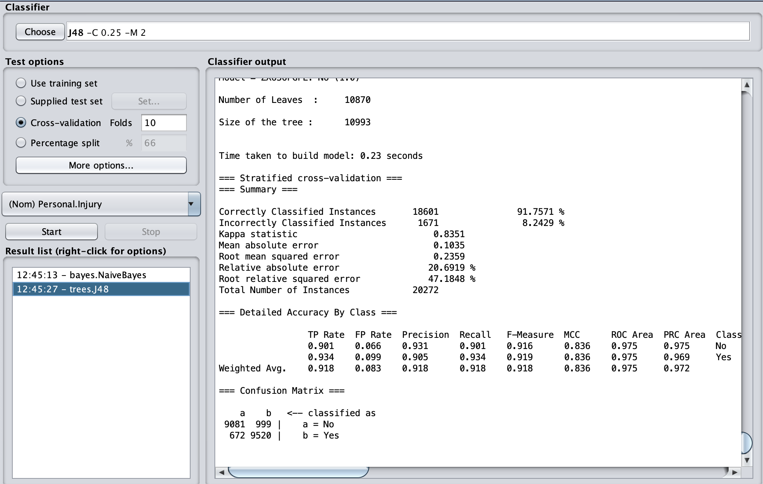

**OneR:**

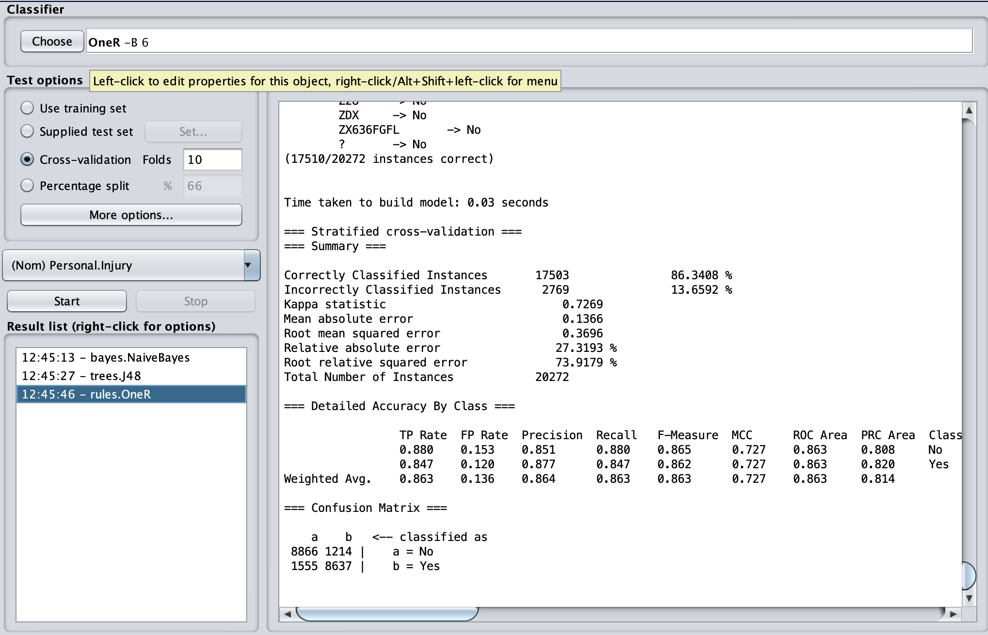

**RandomForest:**

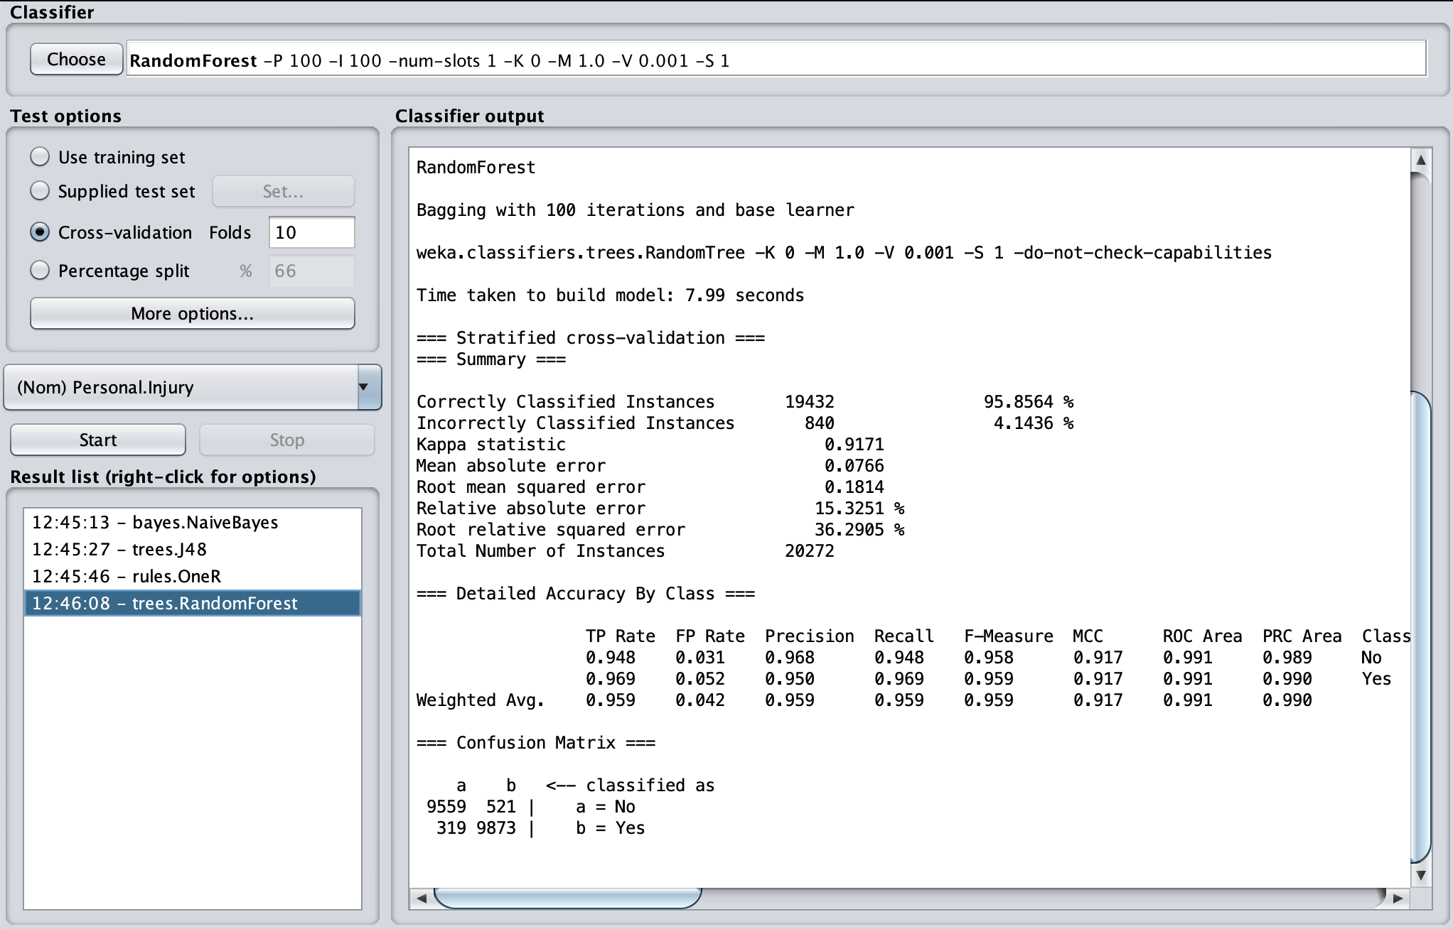

**Compare the test results:**

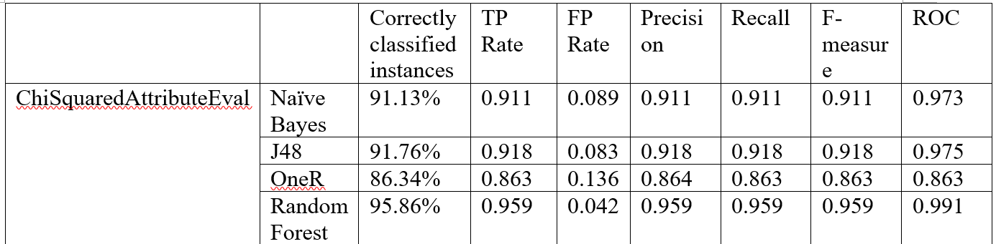

From the test results above, we can see that these four algorithms except OneR have high accuracy of Correctly Classified Instances( above 90%), and the Random Forest has the highest accuracy which is 95.8564%. It also has the highest ROC value, so we can get that the Random Forest has the best performance to build the classification model with ChiSquaredAttributeEval and Ranker method.

1. **Self-selection**

For this one, our goal is to select some attributes manually in weka. We select 8 attributes and one class attributes, it shows below:

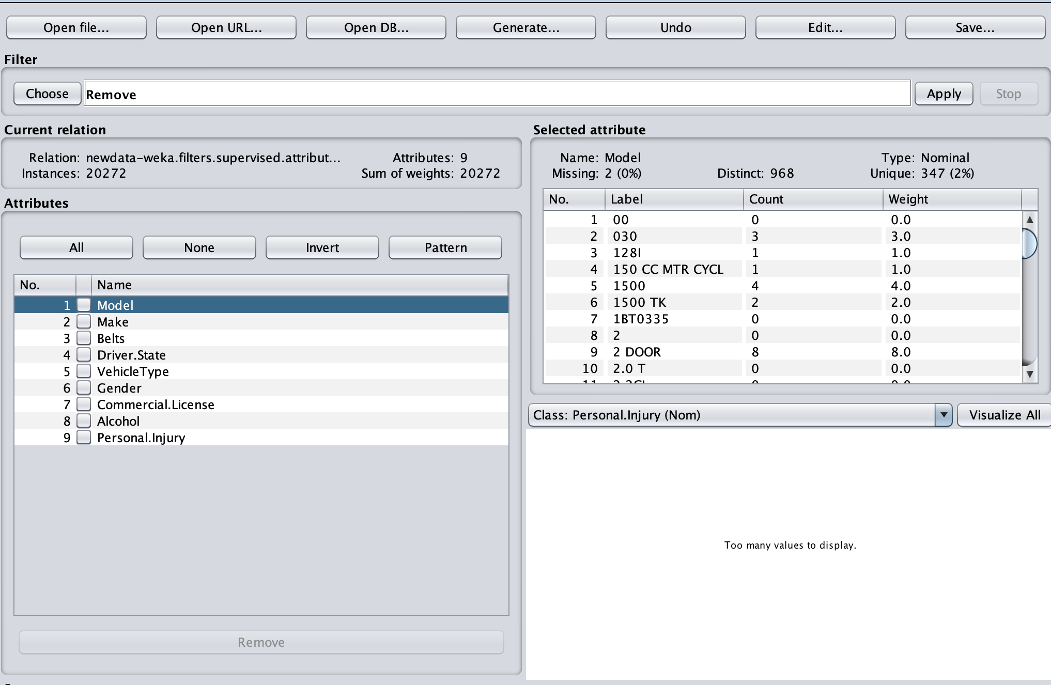

**Naive Bayes:**

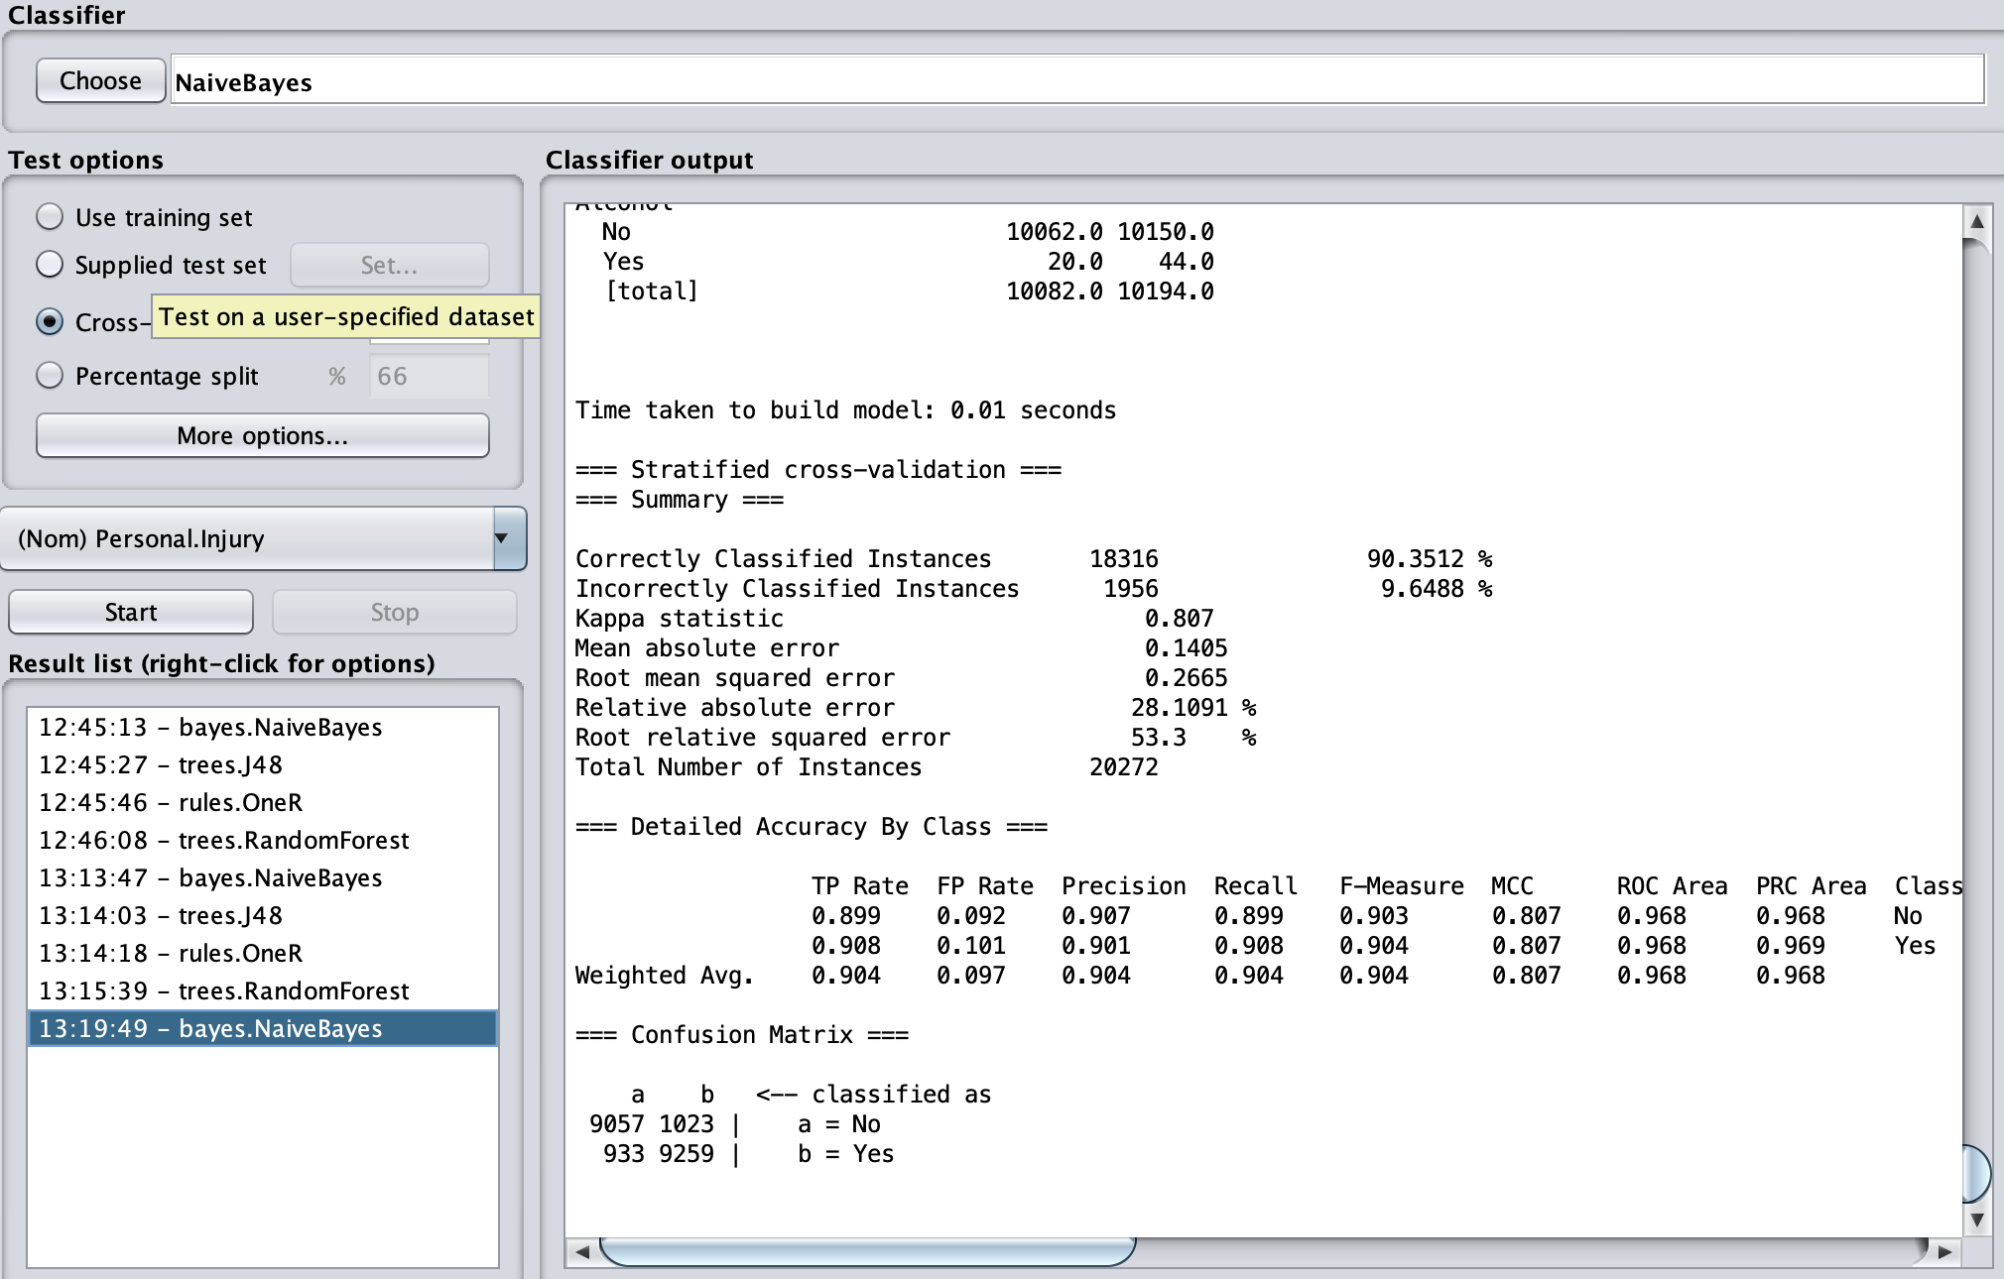

**J48:**

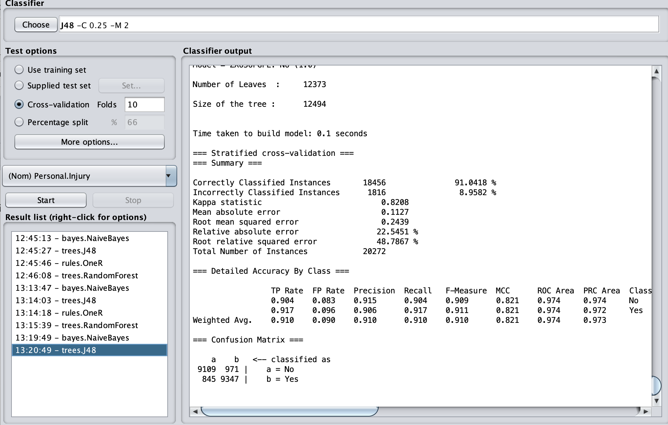

**OneR:**

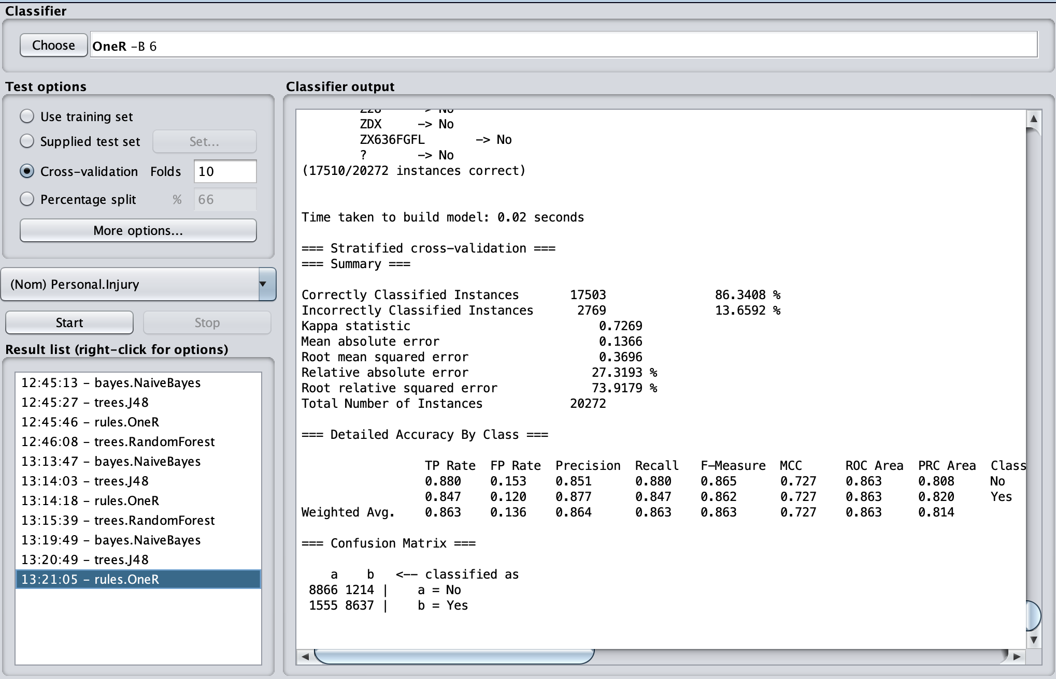

**RandomForest:**

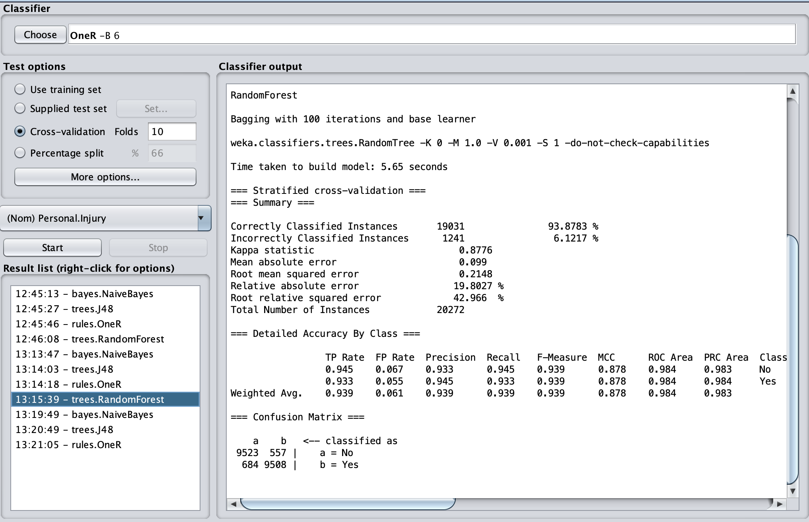

**Compare the test results:**

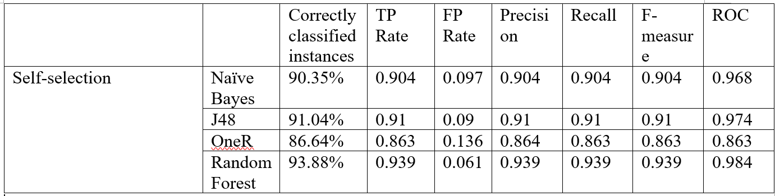

From the test results show above, we can see that the RandomForest has the highest Accuracy of Correctly Classified Instances which is 93.8783%. And also the ROC value is the highest between these four algorithms. So we can conclude that the RandomForest has the best performance with our selected attributes to build the classification model.

**Testing dataset:**

After we built 20 models, we can see that for each algorithm, the Random Forest always has best performance with different evaluator and search method. So we want to use the Random Forest algorithm to build classification model with all five attributes selection methods. From the results above, we can see the accuracy of correctly Classified Instances from these five different selection methods are over 90%, so we can get that the Random Forest has the best performance in building classification models between the algorithms we selected.

Firstly, there are total five good models that are combine with the attribute selection method and classifier:

1. CsfSubsetEval attribute selection with Random Forest classifier
2. GainRationAttributeEval attribute selection with Random Forest classifier
3. InfoGainAttributeEval attribute selection with Random Forest classifier
4. ChiSquaredAttributeEval attribute selection with Random Forest classifier
5. Self-selection attribute selection with Random Forest classifier

however, there is only one best model for the test dataset, according to the following test numbers in the training dataset, the best model that we are going to use in the test dataset is

**ChiSquaredAttributeEval attribute selection with Random Forest classifier.**

The model takes the highest correctly classified instances, the highest TP rate, F-measure and the largest ROC number. The FP rate is the lowest.

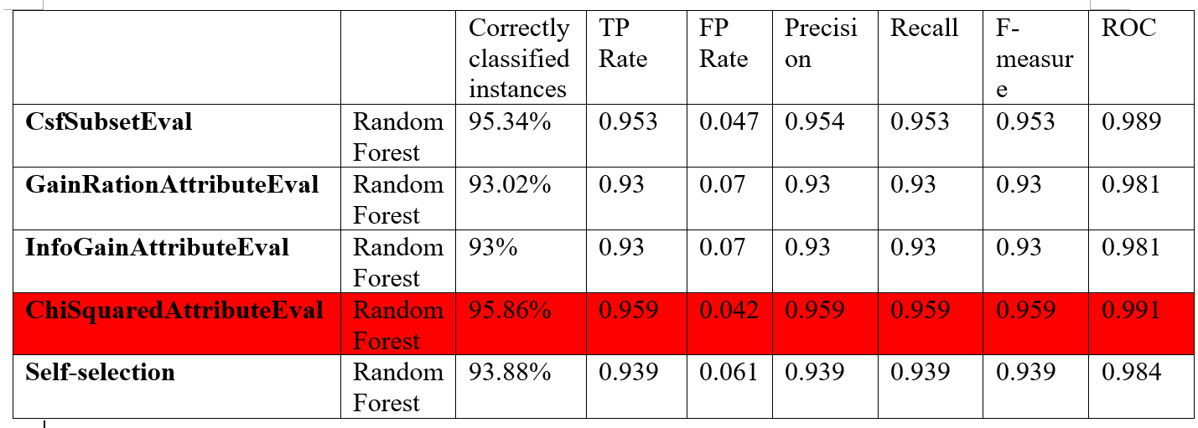

**Evaluator: ChiSquaredAttributeEval Search: Ranker for the test dataset.**

The Correctly classified instances in the test dataset by using ChiSquaredAttributeEval with Random Forest is high as 90.68%. The TP rate is 0.907 and F-measure is 0.942. The PRC area is 0.984. These values shows that the model is best.

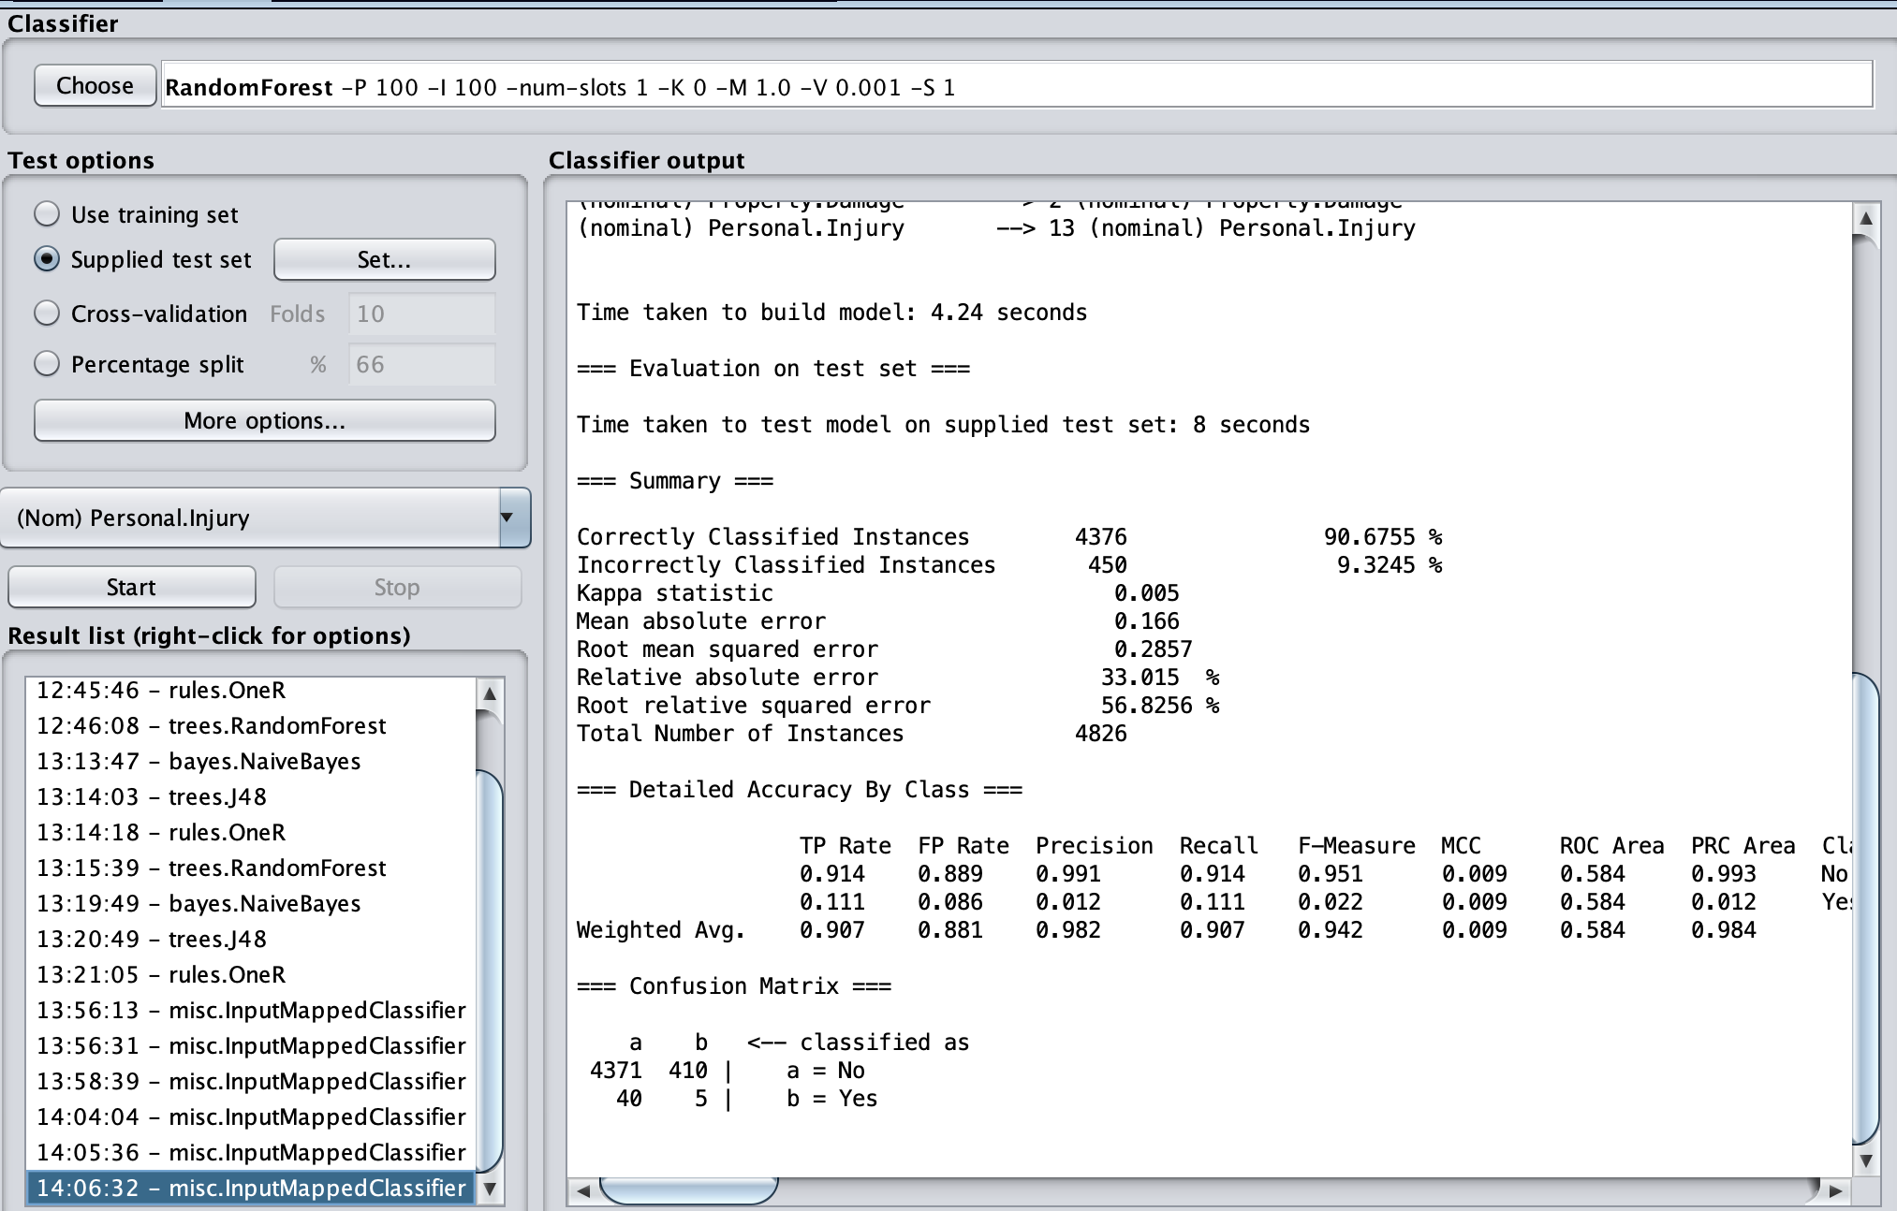

**Conclusion:**

|  |  |  |  |  |  |  |  |  |
| --- | --- | --- | --- | --- | --- | --- | --- | --- |
|  |  | **Correctly classified instances** | **TP Rate** | **FP Rate** | **Precision** | **Recall** | **F-measure** | **ROC** |
| **CsfSubsetEval** | **Naïve Bayes** | **91.31%** | **0.913** | **0.087** | **0.913** | **0.913** | **0.913** | **0.973** |
| **J48** | **91.69%** | **0.917** | **0.083** | **0.917** | **0.917** | **0.917** | **0.976** |
| **OneR** | **86.34%** | **0.863** | **0.136** | **0.864** | **0.863** | **0.863** | **0.863** |
| **Random Forest** | **95.34%** | **0.953** | **0.047** | **0.954** | **0.953** | **0.953** | **0.989** |
| **GainRationAttributeEval** | **Naïve Bayes** | **90.05%** | **0.9** | **0.1** | **0.901** | **0.9** | **0.9** | **0.966** |
| **J48** | **90.16%** | **0.902** | **0.098** | **0.902** | **0.902** | **0.902** | **0.972** |
| **OneR** | **86.34%** | **0.863** | **0.136** | **0.864** | **0.863** | **0.863** | **0.863** |
| **Random Forest** | **93.02%** | **0.93** | **0.07** | **0.93** | **0.93** | **0.93** | **0.981** |
| **InfoGainAttributeEval** | **Naïve Bayes** | **90.05%** | **0.9** | **0.1** | **0.901** | **0.9** | **0.9** | **0.966** |
| **J48** | **90.16%** | **0.902** | **0.098** | **0.902** | **0.902** | **0.902** | **0.972** |
| **OneR** | **86.34%** | **0.863** | **0.136** | **0.864** | **0.863** | **0.863** | **0.863** |
| **Random Forest** | **93%** | **0.93** | **0.07** | **0.93** | **0.93** | **0.93** | **0.981** |
| **ChiSquaredAttributeEval** | **Naïve Bayes** | **91.13%** | **0.911** | **0.089** | **0.911** | **0.911** | **0.911** | **0.973** |
| **J48** | **91.76%** | **0.918** | **0.083** | **0.918** | **0.918** | **0.918** | **0.975** |
| **OneR** | **86.34%** | **0.863** | **0.136** | **0.864** | **0.863** | **0.863** | **0.863** |
| **Random Forest** | **95.86%** | **0.959** | **0.042** | **0.959** | **0.959** | **0.959** | **0.991** |
| **Self-selection** | **Naïve Bayes** | **90.35%** | **0.904** | **0.097** | **0.904** | **0.904** | **0.904** | **0.968** |
| **J48** | **91.04%** | **0.91** | **0.09** | **0.91** | **0.91** | **0.91** | **0.974** |
| **OneR** | **86.64%** | **0.863** | **0.136** | **0.864** | **0.863** | **0.863** | **0.863** |
| **Random Forest** | **93.88%** | **0.939** | **0.061** | **0.939** | **0.939** | **0.939** | **0.984** |

1.At first, we did preprocessing for our raw dataset. Because there are some missing values, outliers and non-relevant values that can affect the performance of classification result. So we learnt how to use R to do the preprocessing for dataset. After that, when we try to do some data visualization, our dataset has too many tuples (over one million) that Weka cannot handle it perfectly, so we realize that Weka is not a good tool when we want to do data mining for a huge dataset. Then we used Weka to pick 1% tuples from dataset, and then separate it into two datasets: training and testing. We also find that if we want to do undersampling to keep balance of class attribute, the SMOTE is the best way to do it, because it will not affect too much on the accuracy of classification result. So we learnt how to data preprocessing and data visualization with R and Weka.

2. From the results of 20 classification models, we found that the RandomForest has the best performance of prediction on our dataset, and the OneR has the worst performance of prediction on our dataset. The combination of the ChiSquaredAttributeEvaland RandomForest is the best model to do prediction on our dataset, it has the highest accuracy(95.86%).

3. The goal of our project is to predict if a driver would get personal injury among some different attributes. Then from the results of attribute selection, we found that the attribute “belt” participates in every model, so we can confirm that the “belt” is making an important role in predicting whether a driver will get personal injury or not.

Reference

<http://weka.sourceforge.net/doc.dev/weka/attributeSelection/CfsSubsetEval.html>

<http://weka.sourceforge.net/doc.stable/weka/attributeSelection/GainRatioAttributeEval.html>

<http://weka.sourceforge.net/doc.dev/weka/attributeSelection/InfoGainAttributeEval.html>

<http://weka.sourceforge.net/doc.stable/weka/attributeSelection/ChiSquaredAttributeEval.html>

**Team members work:**

**Shuo Li: Data preprocessing, test dataset, justification, Final Project.**

**PengYuan: Data classification with 5 selection algorithms, Final Project.**

**Actually we almost do all the works together, no specific individual works. Work together well.**